Trusses (Roller Bed)
Hazards:
Hazards | Controls
Noise | Class 5 hearing protection must be worn. These may be ear plugs or ear muffs.
Manual handling | Use appropriate lifting techniques: bend your knees, not your back. Do not twist. Turn using your feet and keeping your body straight.  Hold timber close to your body.  Gloves are provided and are optional.  Knee pads are provided for the operator on the roller bed.  Avoid maintaining awkward positions for prolonged periods.
Others in the area | Be aware of where people are when moving timber.
Stapler and corrugated fastener operation | Only trained and authorised people are to operate the nail gun.  The operator’s hands must be away from the firing area.  Nail the bottom of the timber first.
Gangnail plates | Plates are sharp, handle by the edges.
Press | Ensure people are out of the way of the press.  Do not stand between the press and the trusses.  Ensure the emergency pucks are working.
Trip hazards | Be aware of where the air hose is. Keep it out of the way.  Other wires are suspended.

PPE: 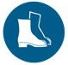

Qualification:
Only trained and authorised staff are to work at the truss press.

Pre-start checks:
Check the condition of the press. Ensure the laser stop is working.
Check the condition of the stapler and corrugated fasteners.
Ensure the hoses are in good condition and the coupling is secure.
Check E-Stops.

Emergency Stops
These are located on the monitor, the side of the roller bed and the side of the press.

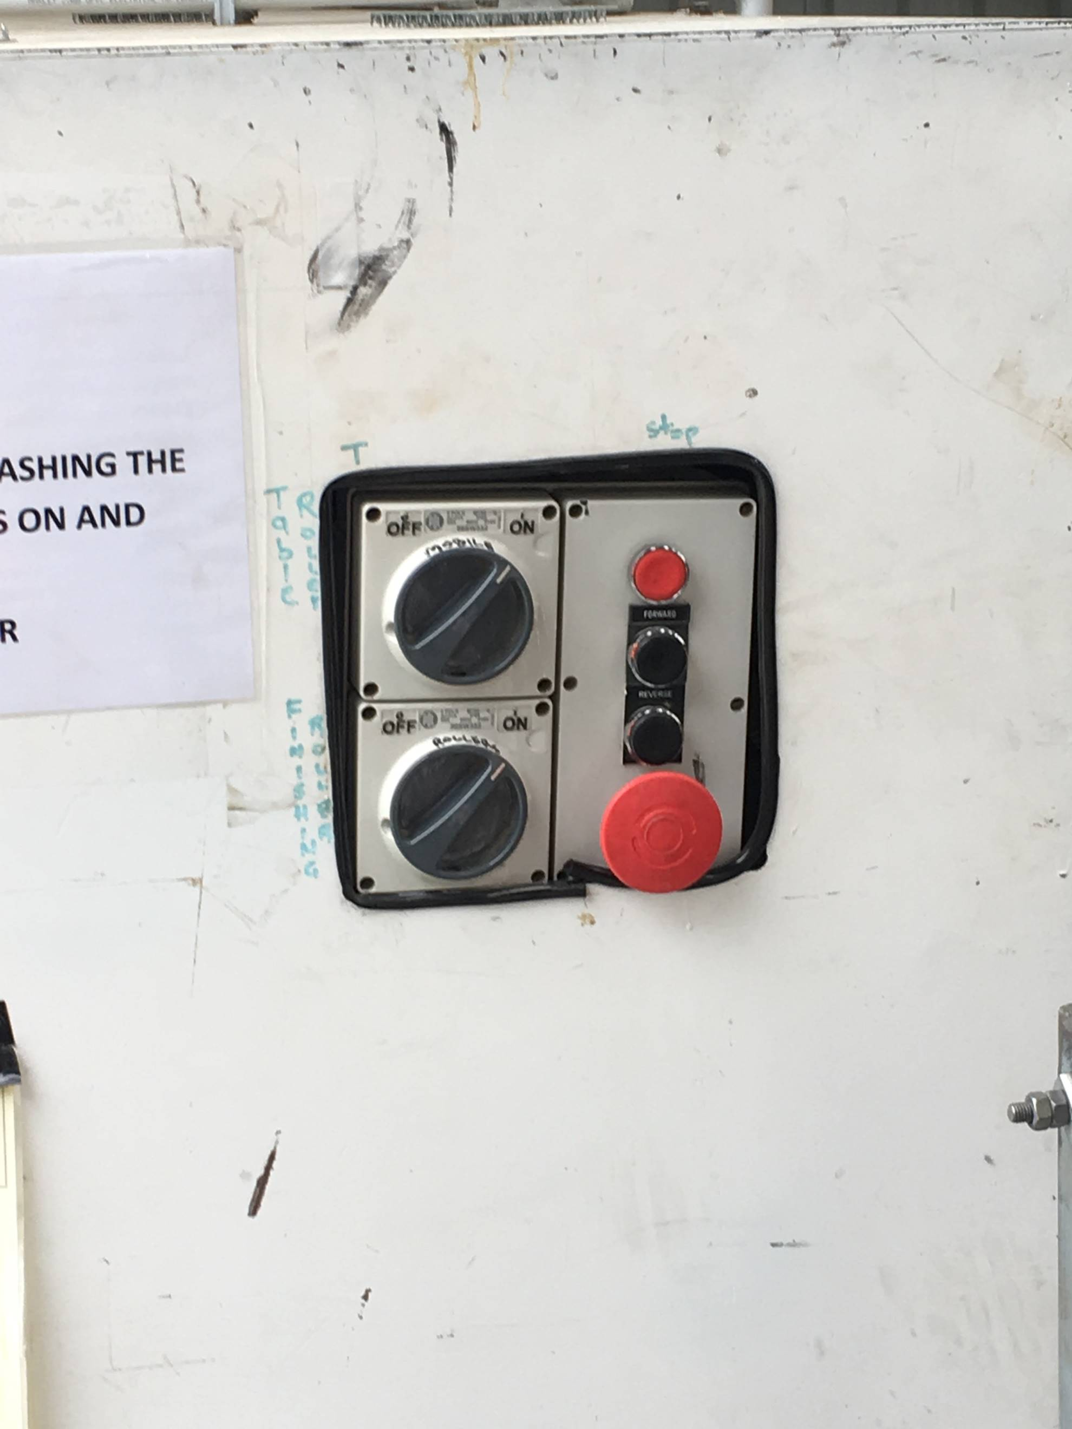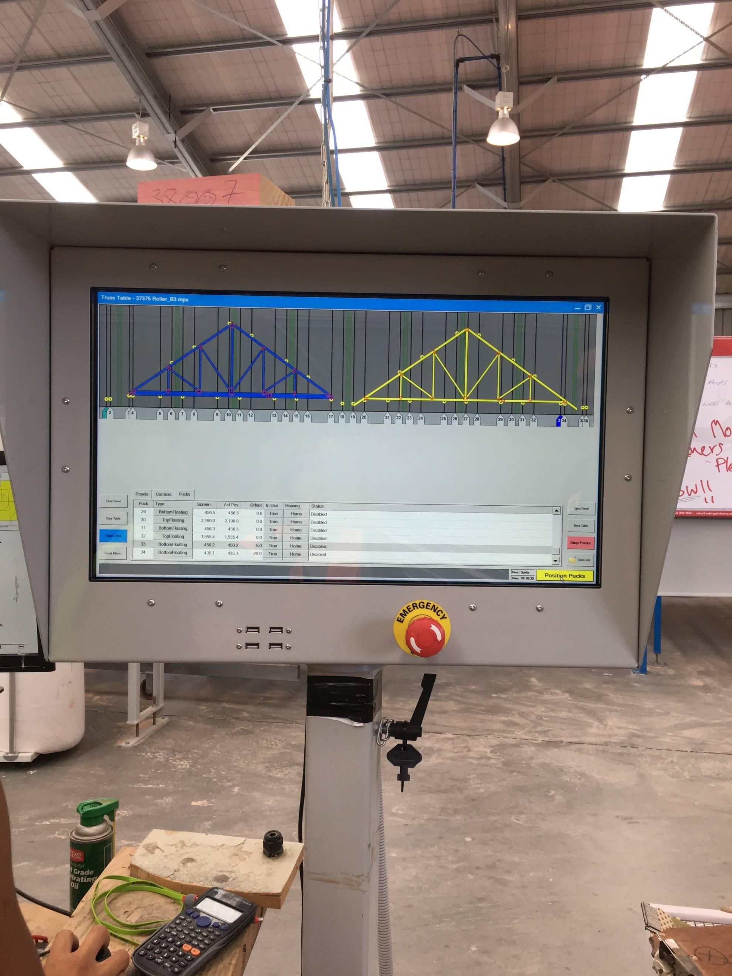

Operation: Trusses (Roller Bed)

 | Step | Action
 | 1 | - Select the job number and set the pucks electronically.  - Manually set any pucks that don’t set automatically.

 | Step | Action
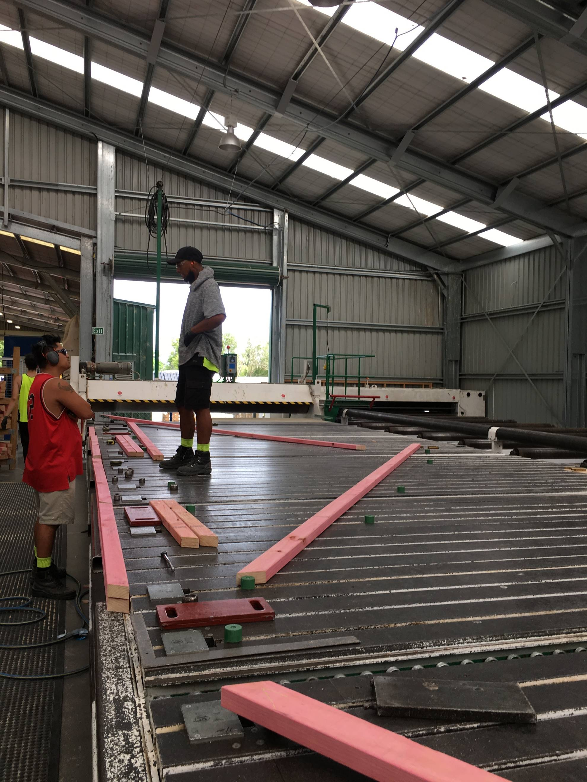 | 2 | - Select timber from the trolley and position against the pucks in accordance with the elevation.  - Place the bottom card first and check the camber.

 | Step | Action
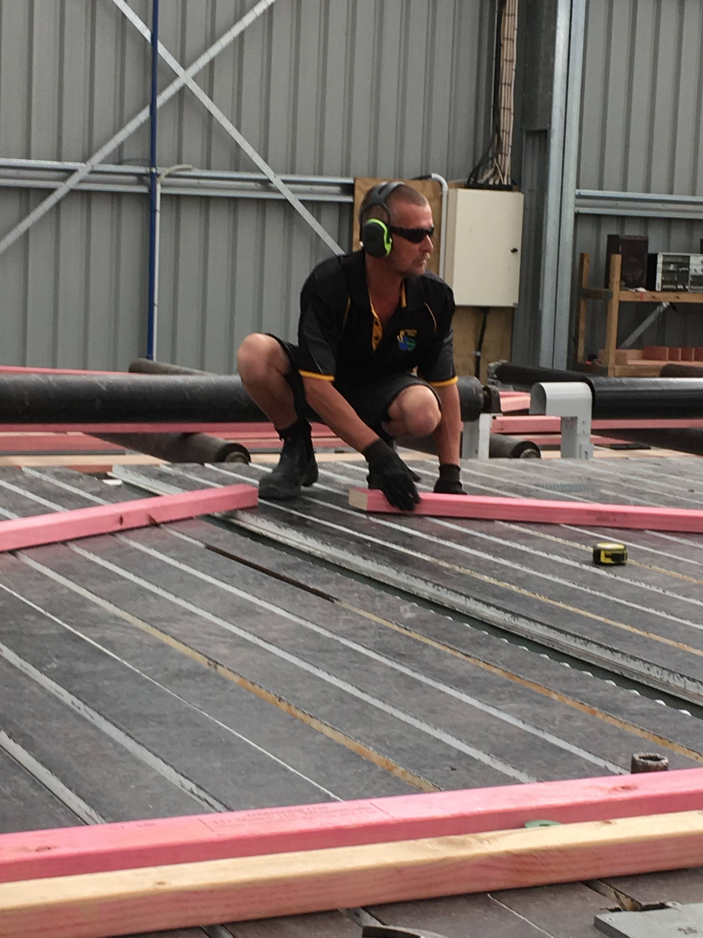 | 3 | - Align the pieces of timber and staple into place.

 | Step | Action
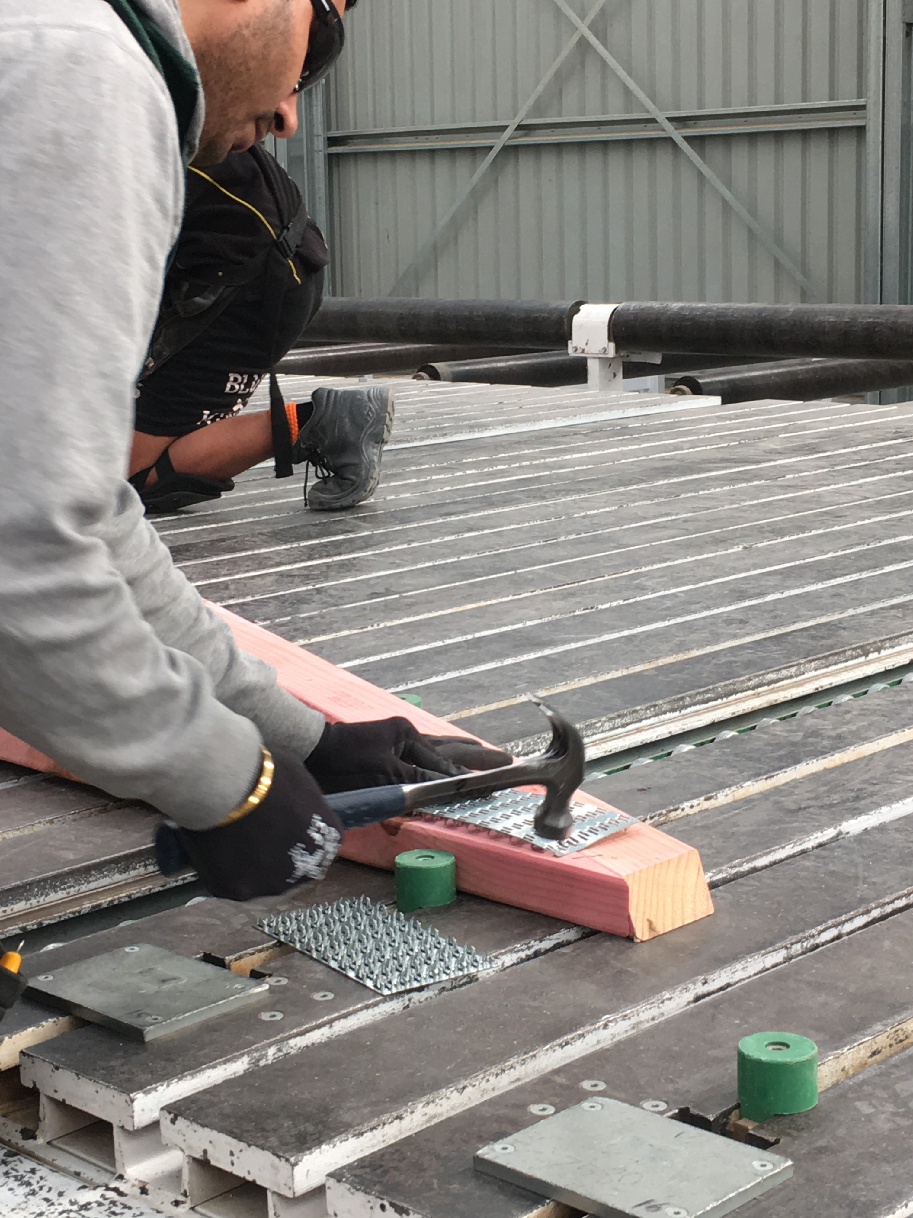 | 4 | - Place the gangnail plates above the join and tap into place with your hammer.  - Use the claw of your hammer to lift the pieces of timber and slide the gangnail plate underneath the join.

 | Step | Action
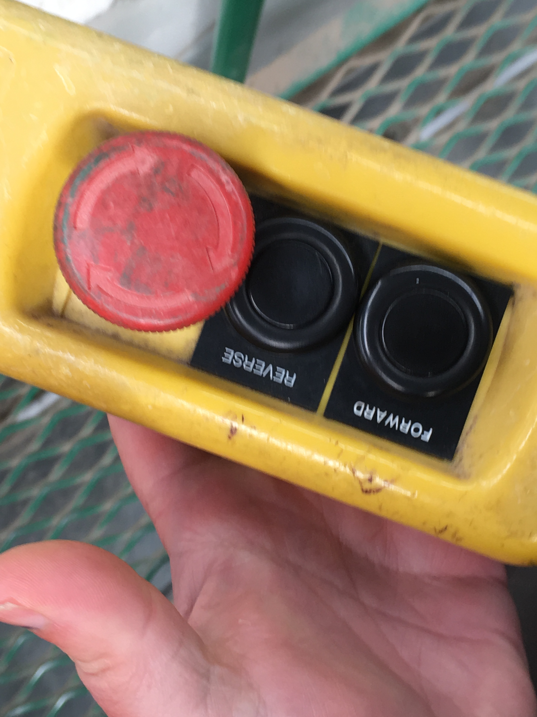 | 5 | - Once the truss is stapled and the gangnail plates are all in place, clear the tools and people from the table.  - Using the on-board control, operate roller by driving the press over the truss to the opposite parking station. Pay attention to the roller bed while the roller is travelling.  Ensure all workers are aware the roller is about to move.  FLASHING RED LIGHT WHEN ROLLER IS TRAVELLING  FLASHING AMBER LIGHT WHEN TRUSS IS GOING THROUGH

 | Step | Action
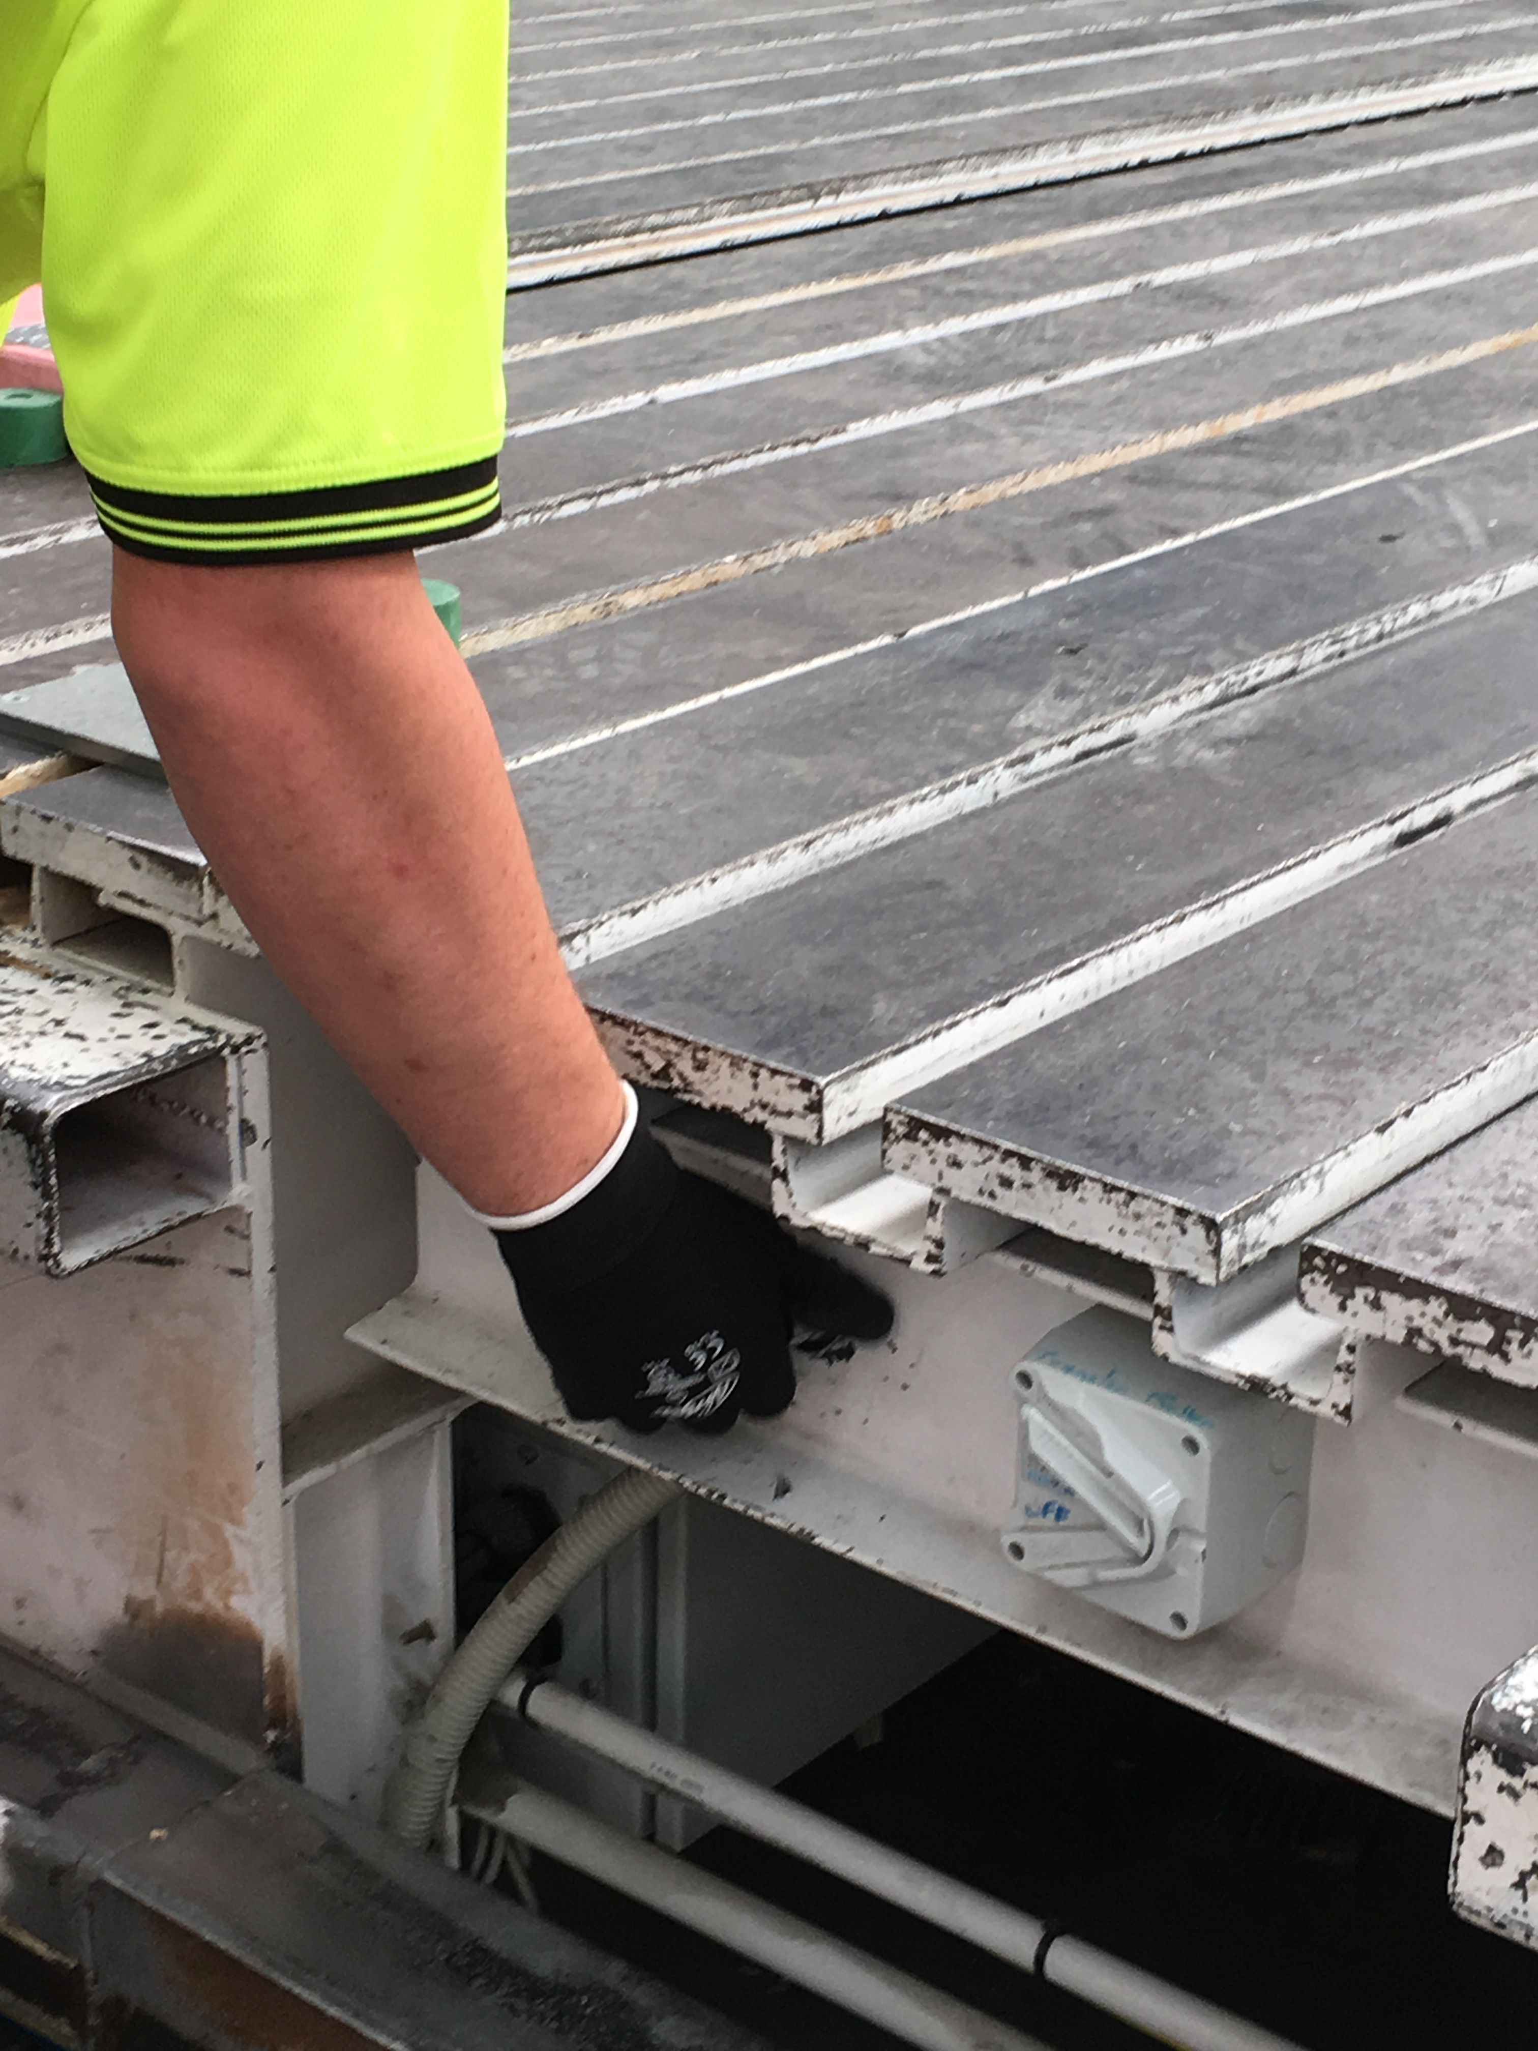 | 6 | - Ensure the rollers are free from debris.  - Turn on the lifters that will lift and move the truss to the transfer roller, which takes it to the transition rollers.  - The transition rollers move the truss to the finishing press.  Ensure workers are clear of the area.  Please note the lifters on the table are split into two lots, so that trusses can be lifted together or from both ends or the middle.

 | Step | Action
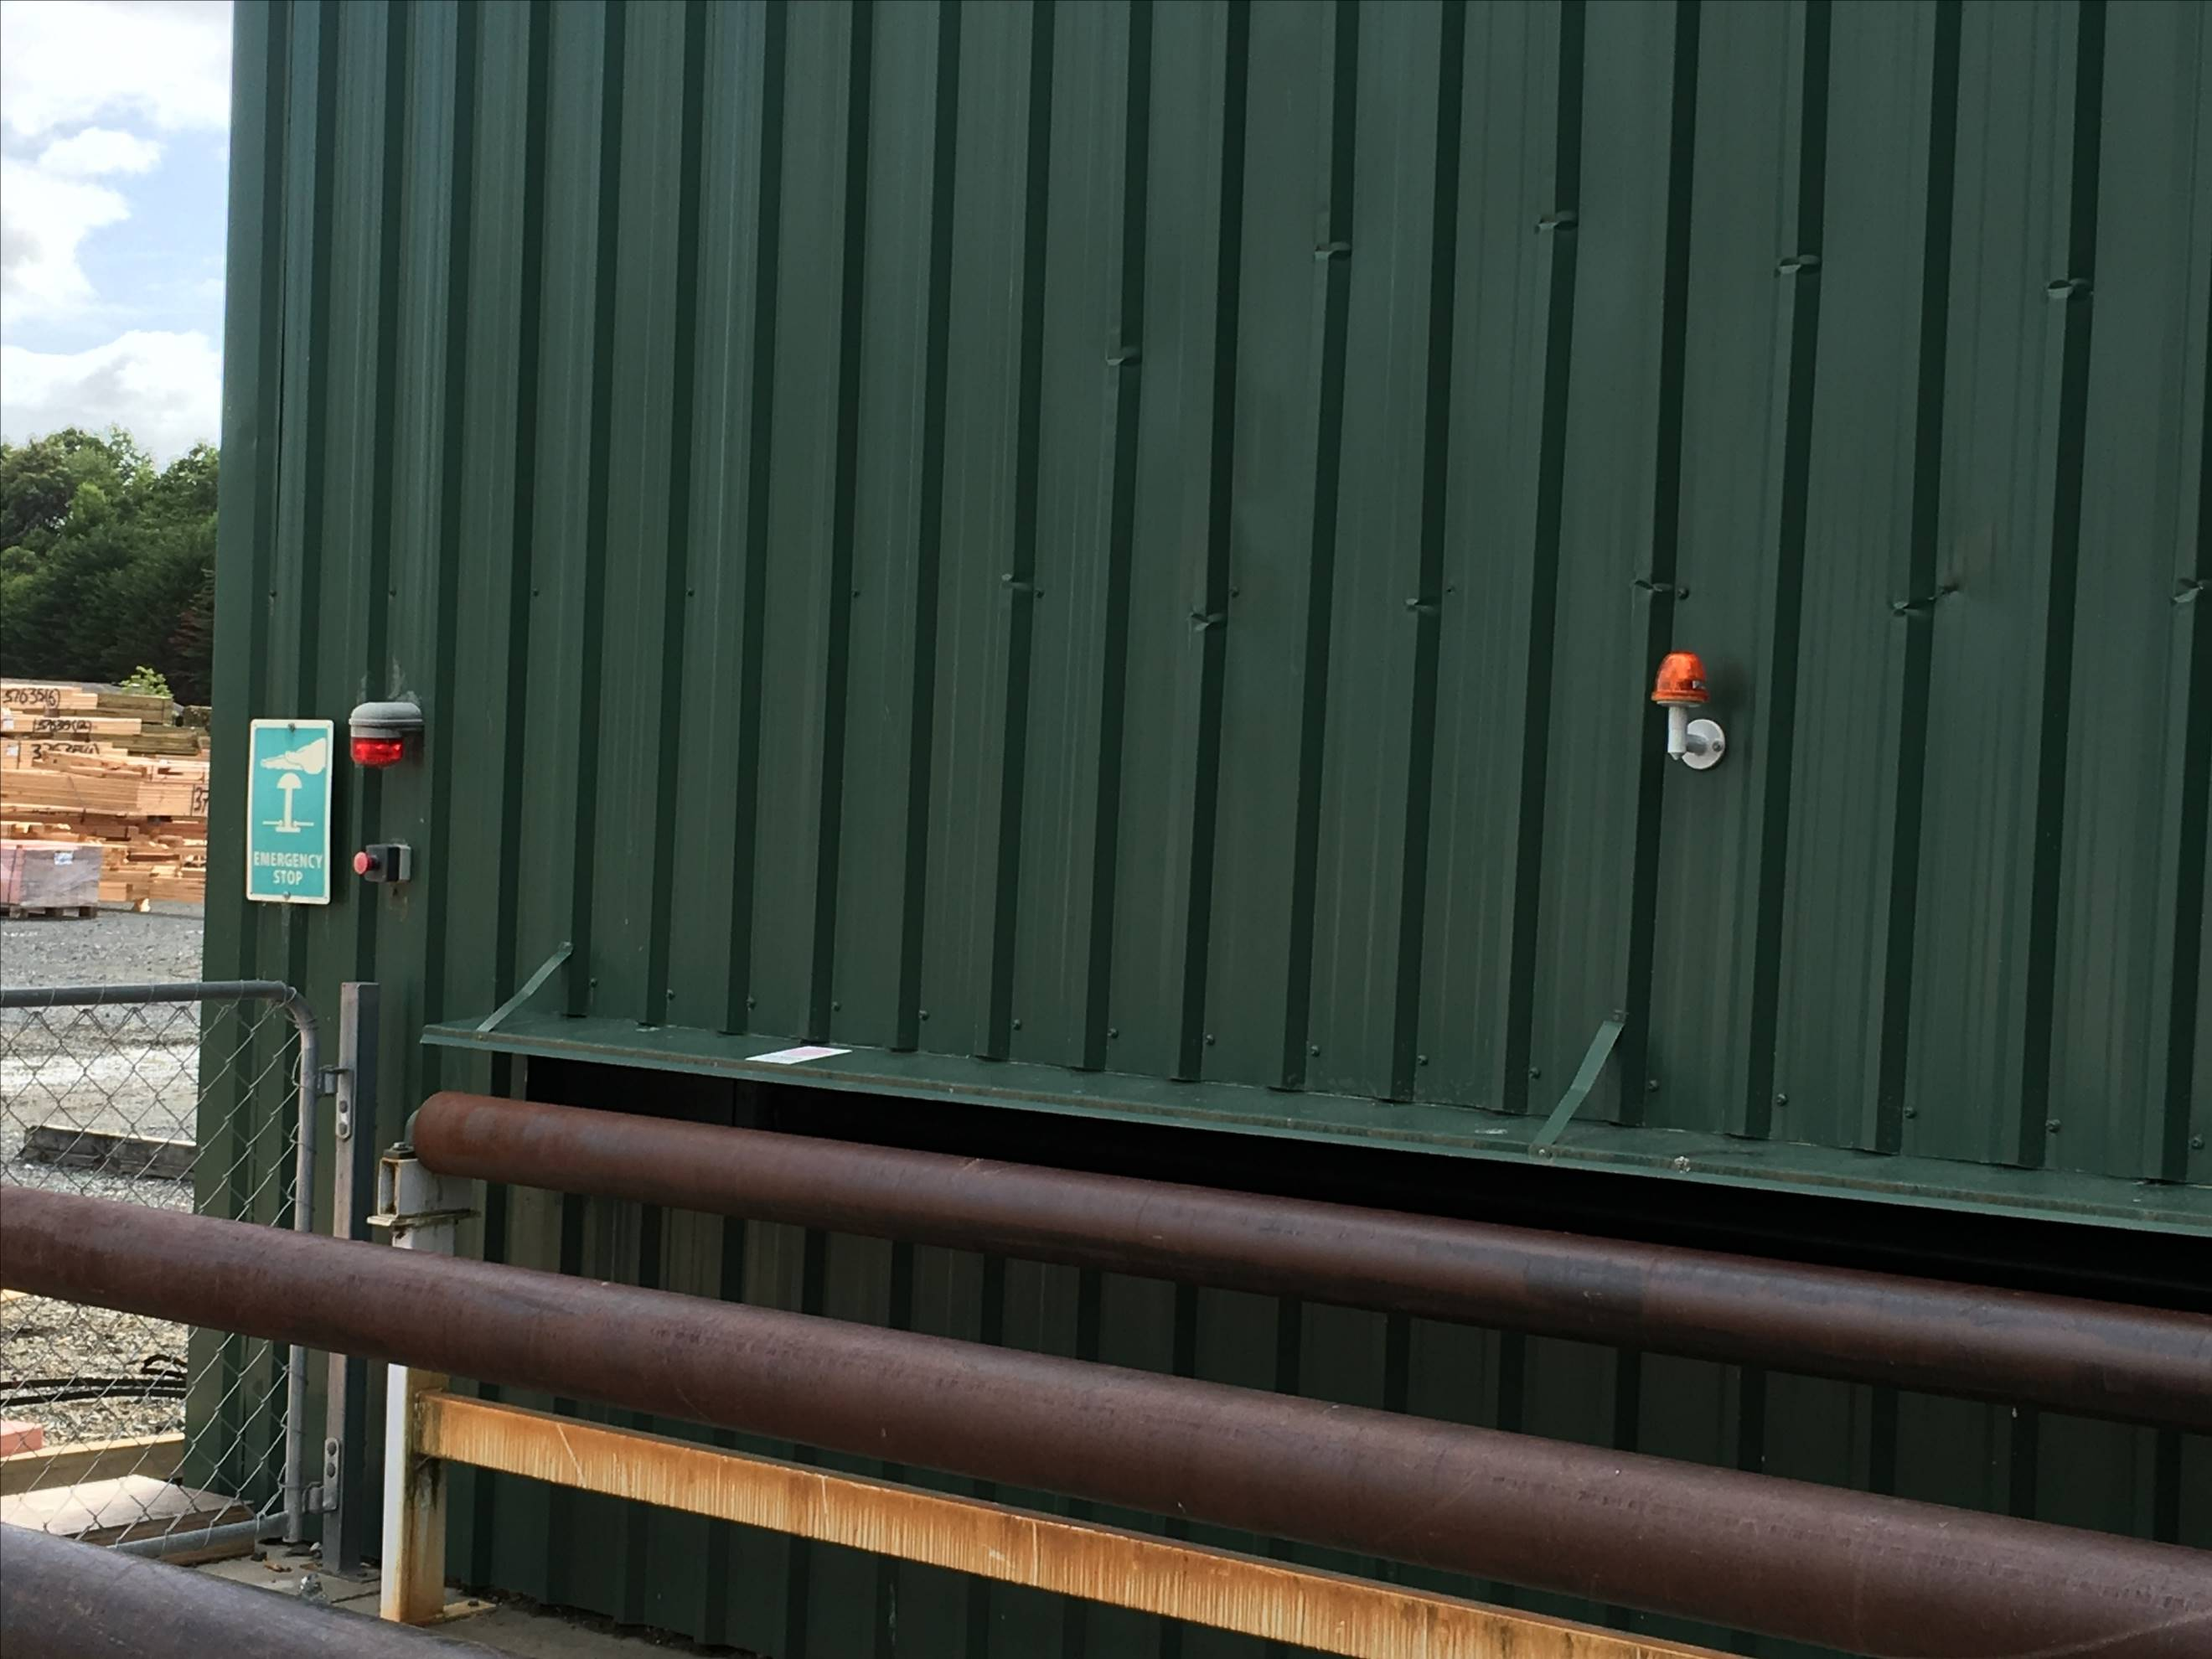  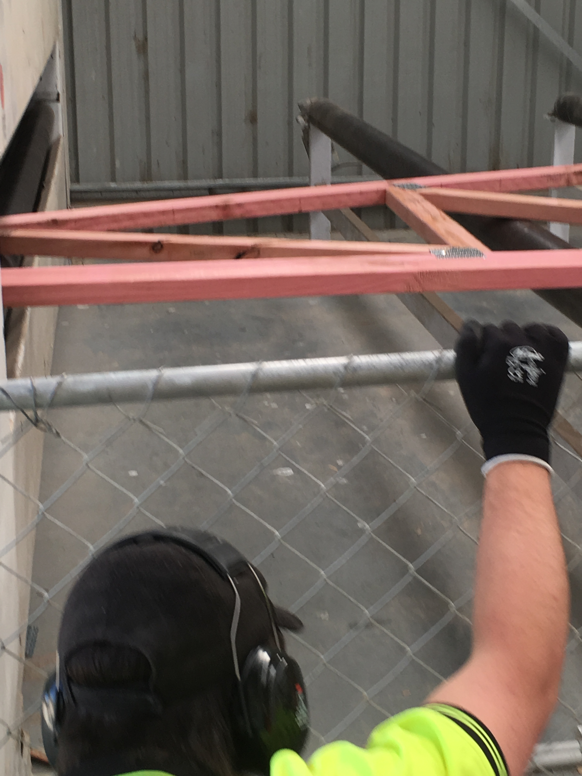 | 7 | - The truss will roll through the finishing press.  - Check for any plates that may have worked loose and replace.  - If the truss becomes stuck, you will need to move it.  - Do not stop the roller while truss is being pressed.  DO NOT STAND BETWEEN THE TRUSS AND THE FINISHING ROLLER  FLASHING RED LIGHTS (AND SIREN) MEAN THE ROLLERS ARE MOVING. FLASHING AMBER LIGHTS MEAN A TRUSS IS COMING THROUGH  - Move the truss off the rollers and onto the pack for that job.  - When the stack is complete, strap with metal strapping.  - Spray paint the job number on the side of the finished packet and staple the packet label on the same side.  - The forklift operator takes the packet away to the correct location in the yard.

 | Step | Action
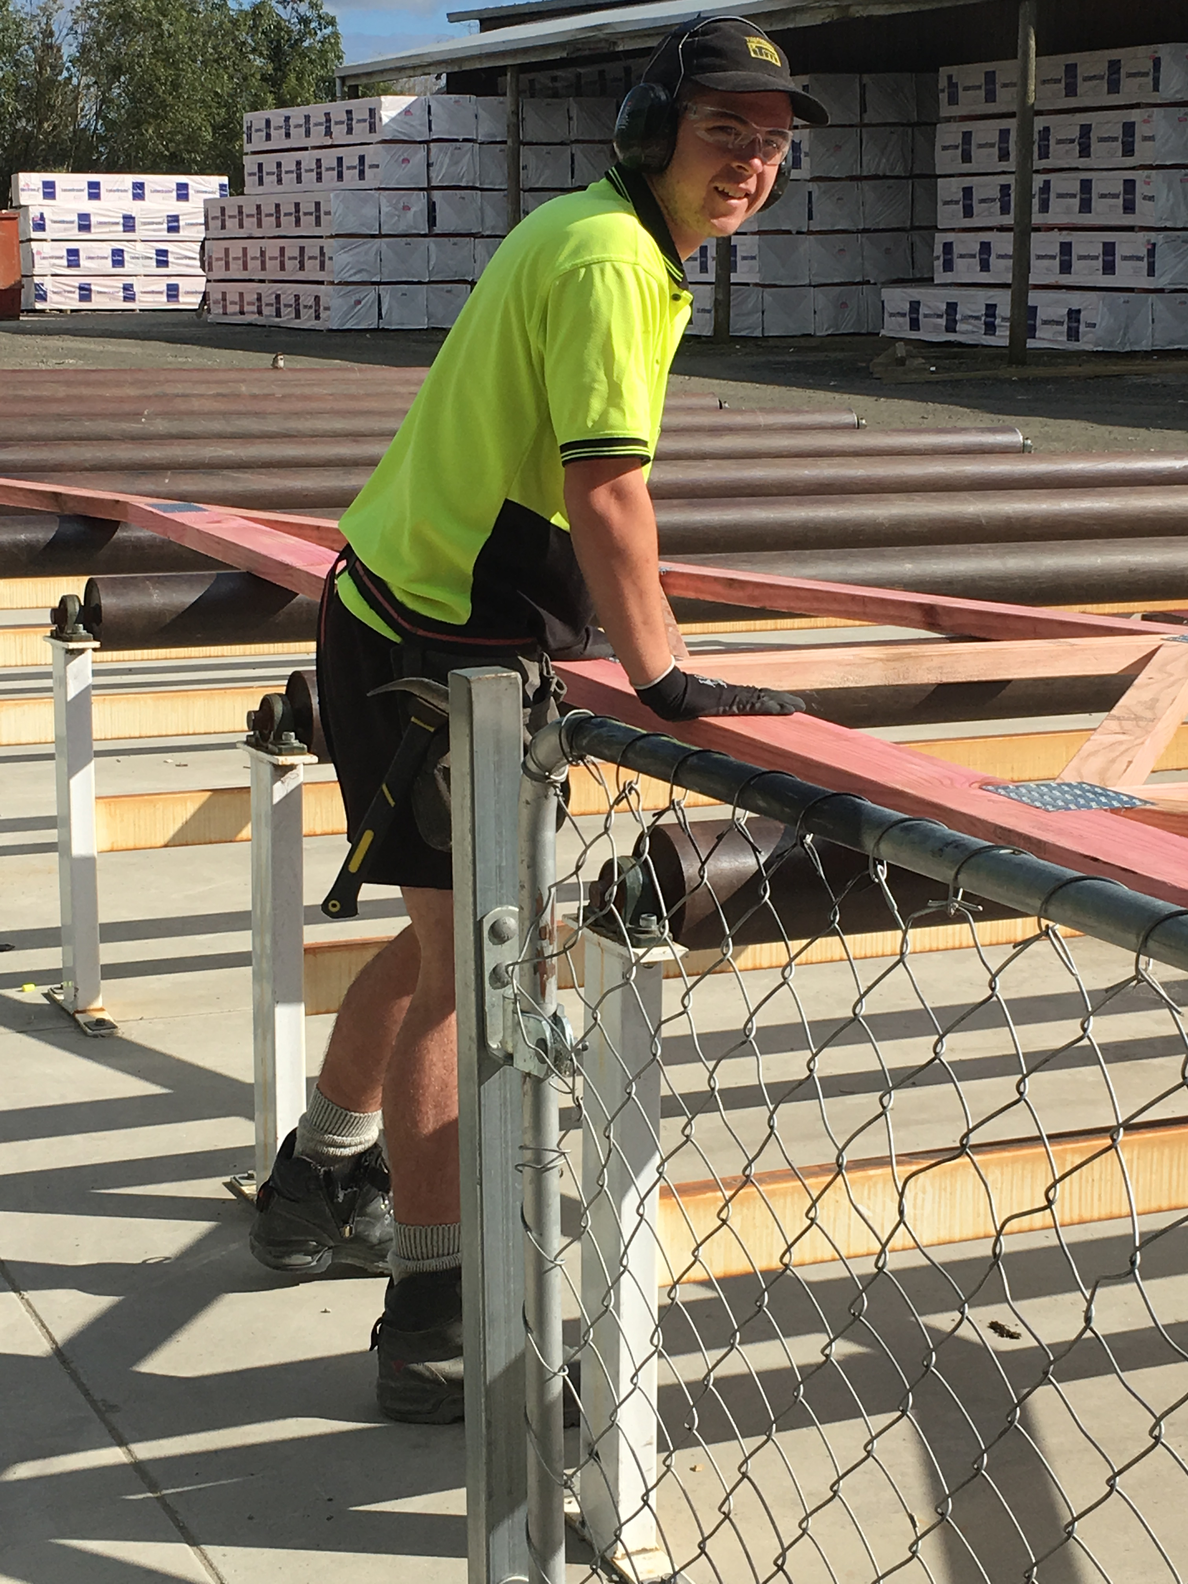 | 8 | - Slide the truss from the rollers onto the stack.  DO NOT STAND IN THE GATED AREA OUTSIDE THE FINISH ROLLER

Shut Down:
Tidy up the area.
Turn off the press.
Turn off the computer.

DATE | TRAINEE NAME | SIGNATURE | TRAINER | SIGNATURE

