Pull Out Wadkins Saw
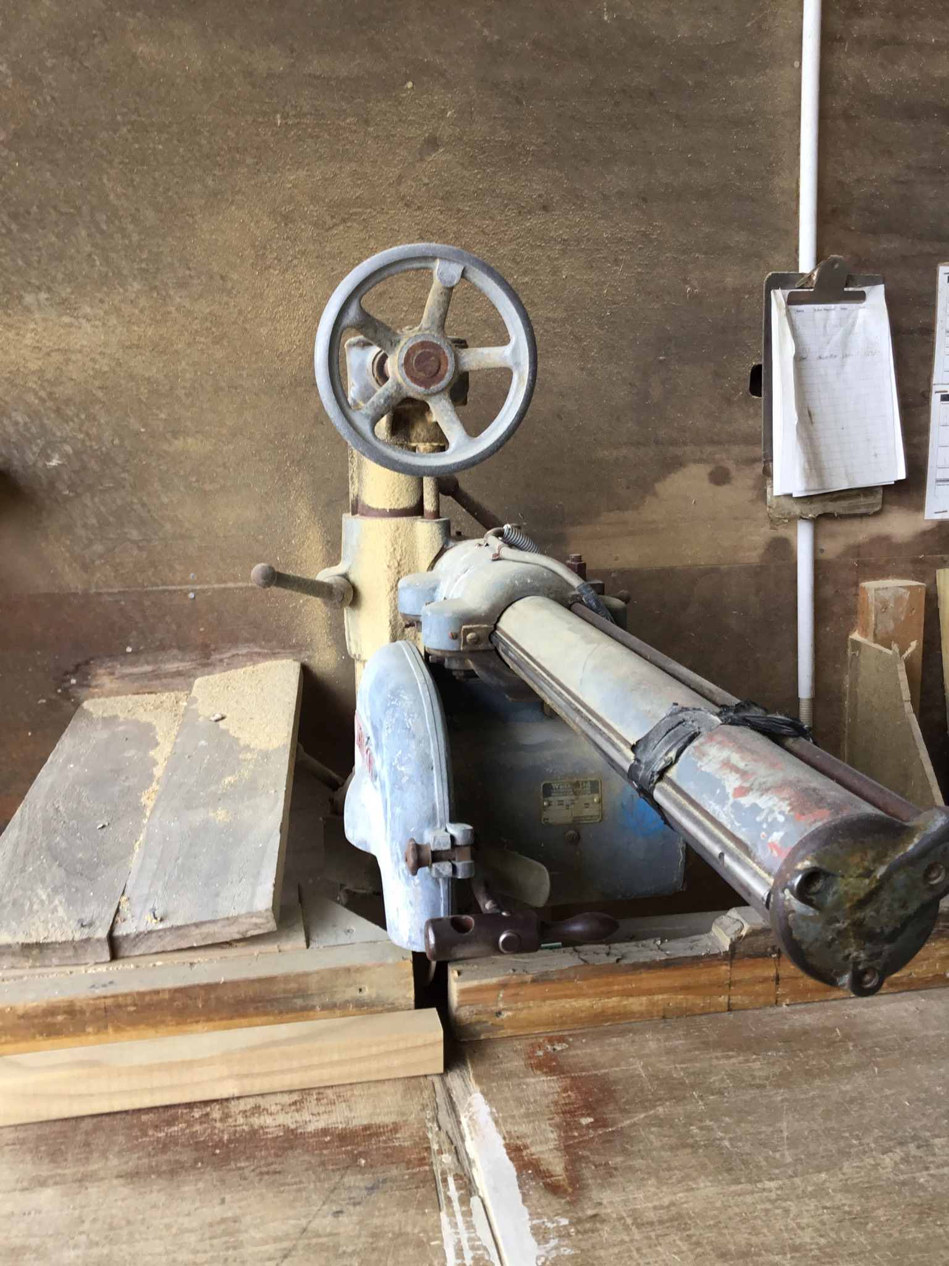

Hazards | Controls
Noise | Class 5 hearing protection must be worn. These may be ear plugs or ear muffs.
Manual handling | Use appropriate lifting techniques: bend your knees, not your back. Do not twist. Turn using your feet and keeping your body straight.  Hold timber close to your body.  Gloves are provided and are optional.  Avoid maintaining awkward positions for prolonged periods.
Others in the area | Be aware of where people or other equipment are when moving timber.
Trip hazards | Keep the area clear from clutter. Clean as you go
Cut points | Guards must be fitted. Keep hands and other body parts away from pinch points

PPE: 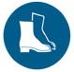 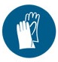Optional

Qualification:
Only trained, authorised and signed-off staff are to work at the pull out saw.

Emergency Stop:

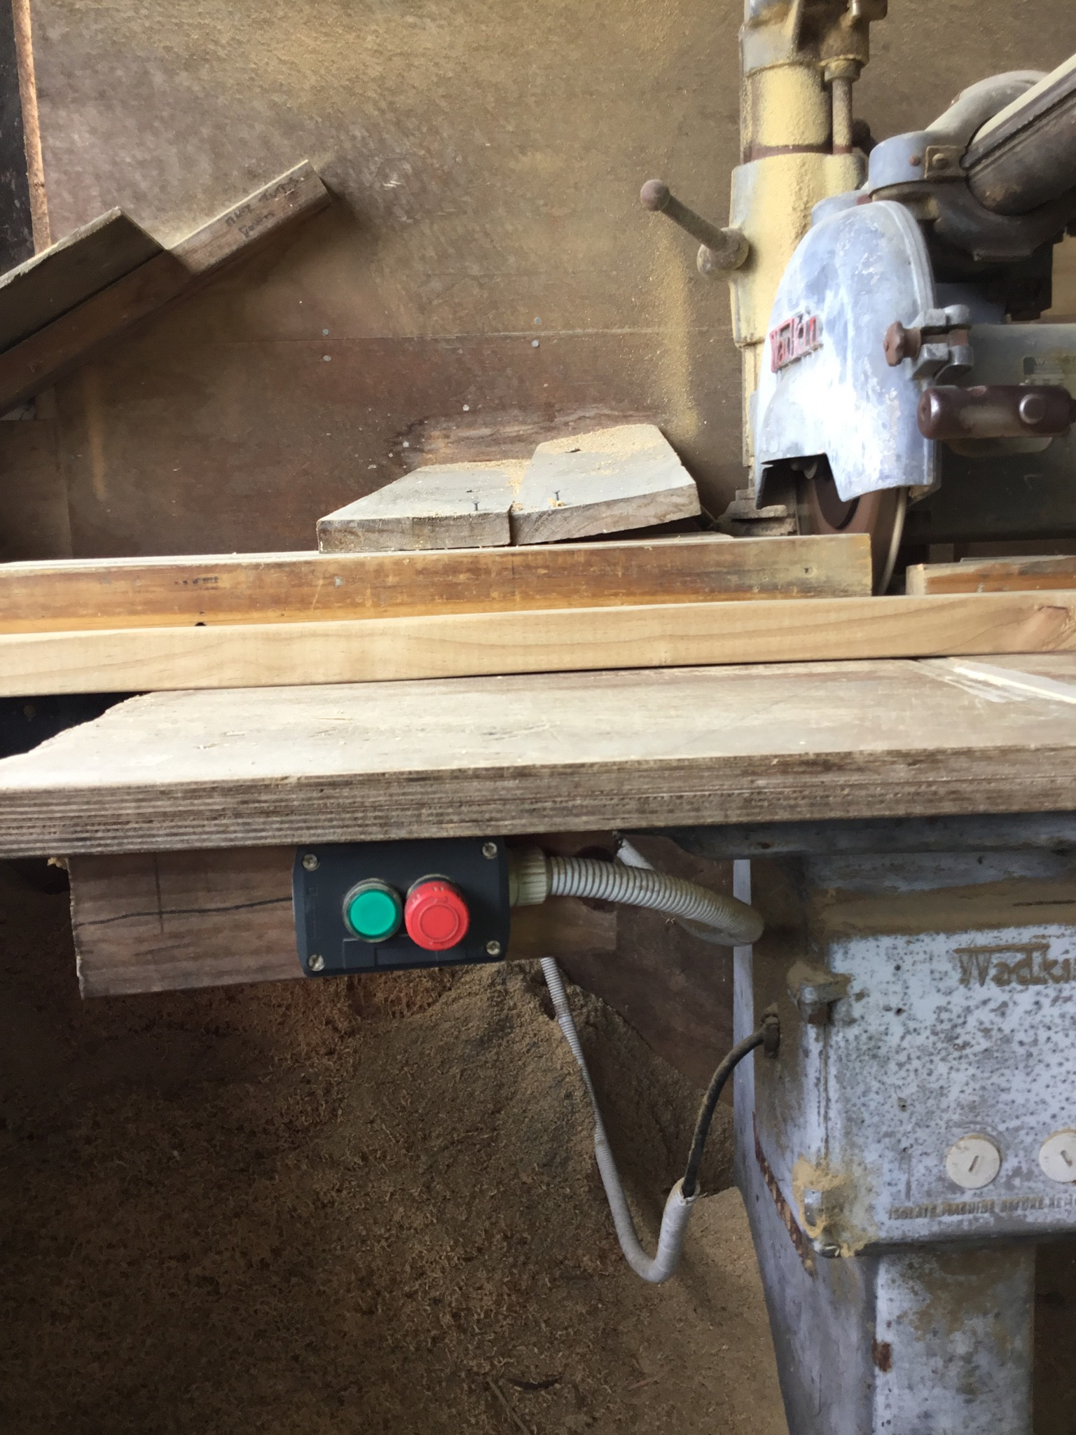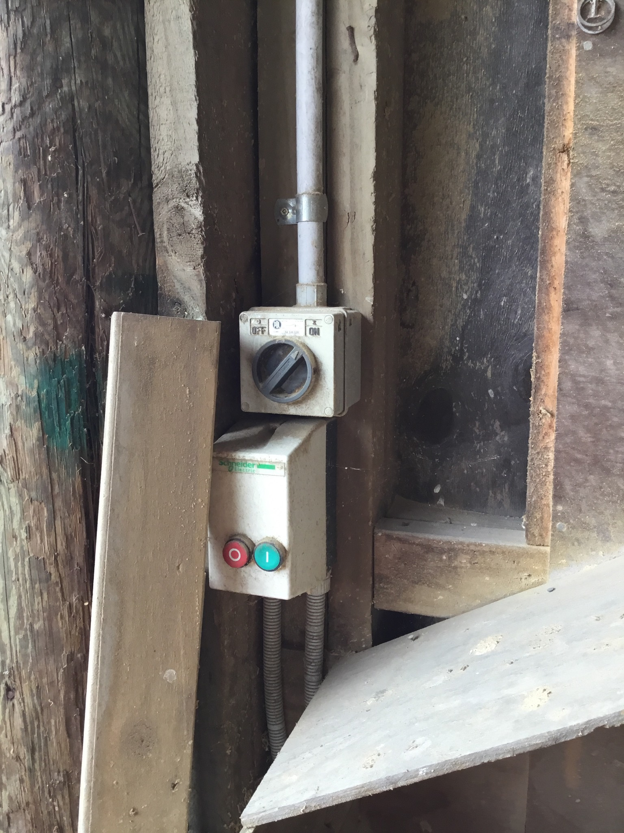

Pre-start checks:
Clear the work area of any clutter, both on the infeed and outfeed sides.
Remove any packets of timber that are in the way.
Cone off the area if using a trolley.

Operation: Pull Out Saw

 | Step | Action
 | 1 | - Turn on the main switch on the wall.
 | 2 | - Adjust the wheel to get the correct height.
 | 3 | - Turn on the pull out saw.  - Check the emergency stops are out.
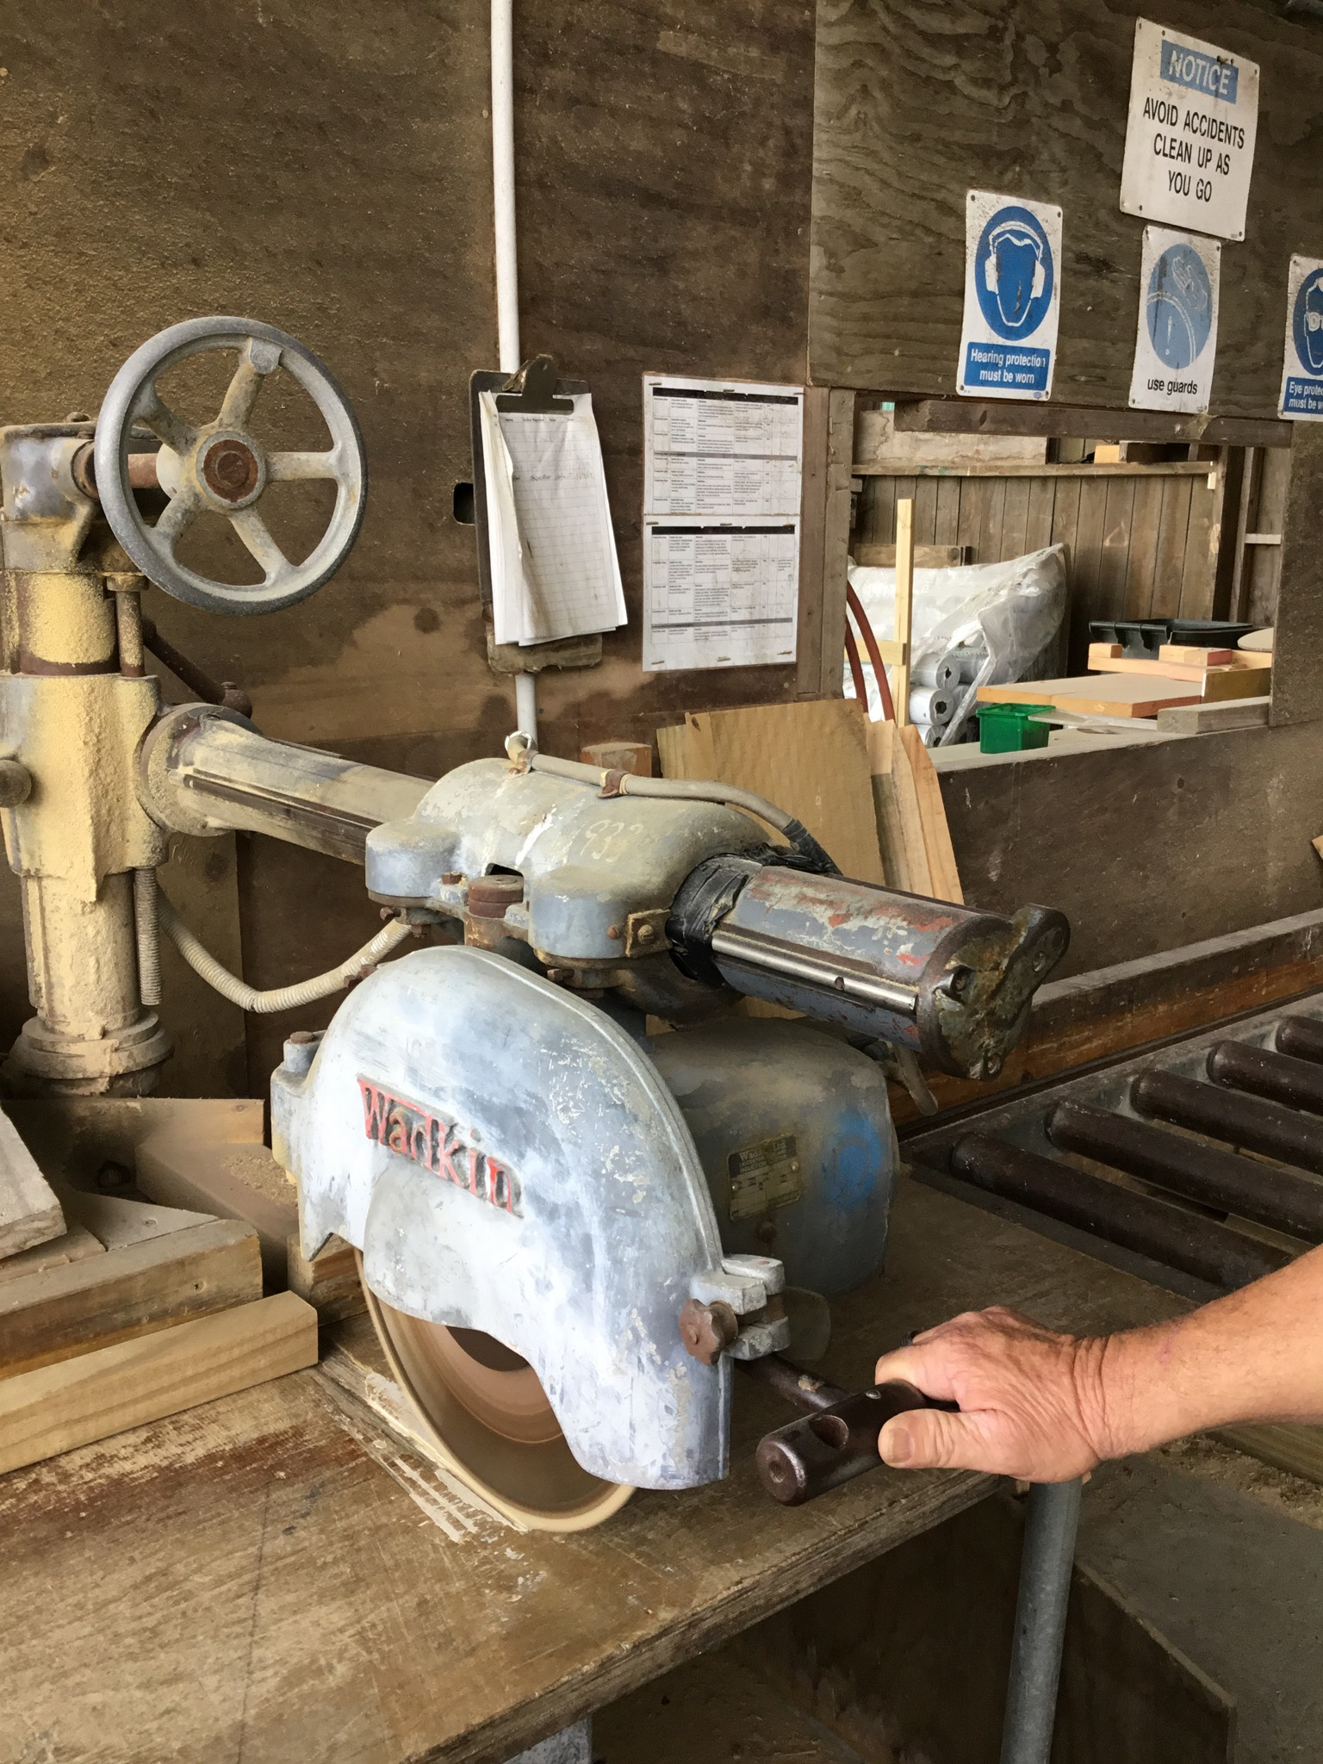 | 4 | - Place the timber on the roller and butt up against the guide.  - Pull out the saw, and push back into place, after making the cut.
 | 5 | - Remove timber and place on trolley or take to the next location.

Shut Down:
Turn off the pull out saw using the emergency stop.
Turn off the main switch on the wall.
Tidy up the area.
Hand in any paperwork.

DATE | TRAINEE NAME | SIGNATURE | TRAINER | SIGNATURE

