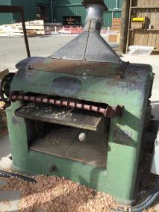
Hazards:
Planer

Hazards | Controls
Noise | Class 5 hearing protection must be worn. These may be ear plugs or ear muffs.
Dust or timber shavings | Extraction system must be used. Safety glasses must be worn.
Manual handling | Use appropriate lifting techniques: bend your knees, not your back. Do not twist. Turn using your feet and keeping your body straight. Hold timber close to your body.  Gloves are provided and must be used.  Avoid maintaining awkward positions for prolonged periods.
Others in the area | Be aware of where people or other equipment are when moving timber.
Trip hazards | Keep the area clear from clutter. Clean as you go.

PPE:

Qualification:
Only trained, authorised and signed-off staff are to work at the planer.

Emergency Stop:
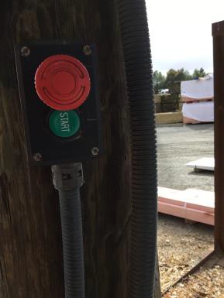
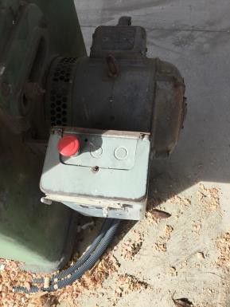
On the post beside the planer On the side of the planer

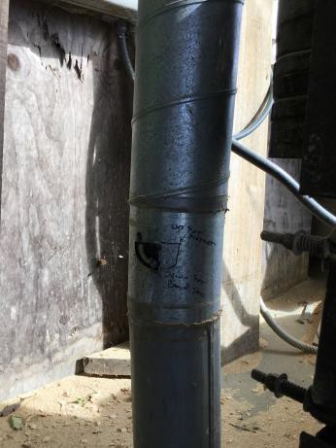Pre-start checks:
Clear the work area of any clutter, both on the infeed and outfeed sides.
Remove any packets of timber that are in the way. Cone off the area if using a trolley.
Ensure the extraction bin is not full. If it is, empty it.

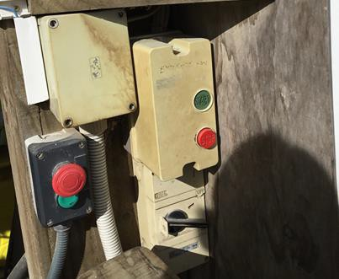Operation: Planer

 | Step | Action
 | 1 | Turn on the extraction system.
 | 2 | Check the flap to make sure it is set for planer.
 | 3 | Turn on the main power (on the post).  Check all emergency stops are out.

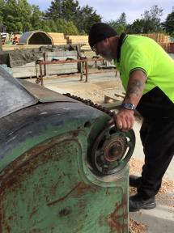 | 4 | Adjust height guide using the wheel on the left of the planer. Place the timber on the planer, judging the height for the timber by eye.
 | 5 | Turn on the planer and allow it to get up to speed. This will take about 30 seconds.
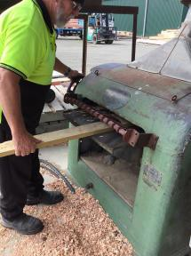 | 6 | Guide the timber into the planer. Let go once it starts to move.  Go to the other side of the planer and support the timber as it is ejected.  Place the timber on the trolley, or take to the next work station.

Shut Down:
Turn off the planer using either emergency stop. Be aware the machine may be hot so do not touch it.
Turn off the extraction system. Tidy up the area.
Hand in any paperwork.

DATE | TRAINEE NAME | SIGNATURE | TRAINER | SIGNATURE

