Hazards:
Nail Gun
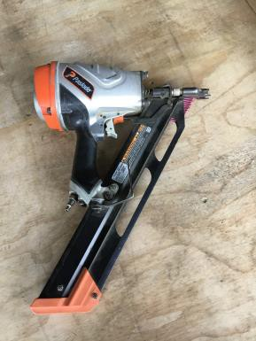

Hazards | Controls
Nail hitting operator | The operator’s hands must be away from the firing area. Always fire the gun away from yourself.
Noise | Class 5 hearing protection must be worn. These may be ear plugs or ear muffs.
Manual handling | Use appropriate lifting techniques: bend your knees, not your back. Do not twist. Turn using your feet and keeping your body straight. Hold timber close to your body.  Gloves are provided and are optional.  Avoid maintaining awkward positions for prolonged periods.
Others in the area | Ensure that there is no one in the firing range.
Trip hazards | Keep the area clear from clutter. Clean as you go.

PPE: Optional

Qualification:
Only trained, authorised and signed-off staff are to operate the nail gun.

Pre-start checks:
Clear the work area of any clutter, both on the infeed and outfeed sides. Remove any packets of timber that are in the way.
Cone off the area if using a trolley.

Operation: Nail Gun

 | Step | Action
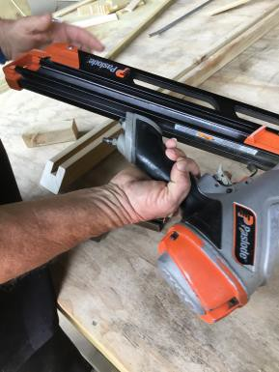 | 1 | Slide the nails into the gun.
 | 2 | Connect the gun to the air hoses, making sure the hoses are out of the way.
 | 3 | Position the timber to be nailed.  Ensure your hands are out of the firing range.  Place the nail gun in position and pull the trigger.
 | 4 | Put the gun down when not using it.
 | 5 | Remove timber and place on trolley or take to the next location.

Shut Down:
Disconnect the gun from the air hoses. Tidy up the area.
Hand in any paperwork.

DATE | TRAINEE NAME | SIGNATURE | TRAINER | SIGNATURE

