Manually Operated Auto-Nailer
Hazards:
Hazards | Controls
Noise | Class 5 hearing protection must be worn. These may be ear plugs or ear muffs.
Manual handling | Use appropriate lifting techniques: bend your knees, not your back. Do not twist. Turn using your feet and keeping your body straight.  Hold timber close to your body.  Gloves are available for staff to use.
Auto-nailer gun operation | The timber must be clamped and the sensors at the nail guns must be covered to illuminate the gun fire button.  Keep away from the firing area.
Nail gun operation | Only trained and authorised people are to operate the nail gun.  The operator’s hands must be away from the firing area.  Nail the bottom of the timber first.
Trip hazards | Be aware of where the air hose is. Keep it out of the way.
Pushing trolleys | Trolleys are fitted with quality, sealed wheels and are well maintained.

PPE:

Qualification:
Only trained, authorised and signed-off staff are to work at the manually operated auto-nailer.

Pre-start checks:
Check the condition of the nail gun. Ensure the hoses are in good condition and the coupling is secure.

Operation: Manually Operated Auto Nailer

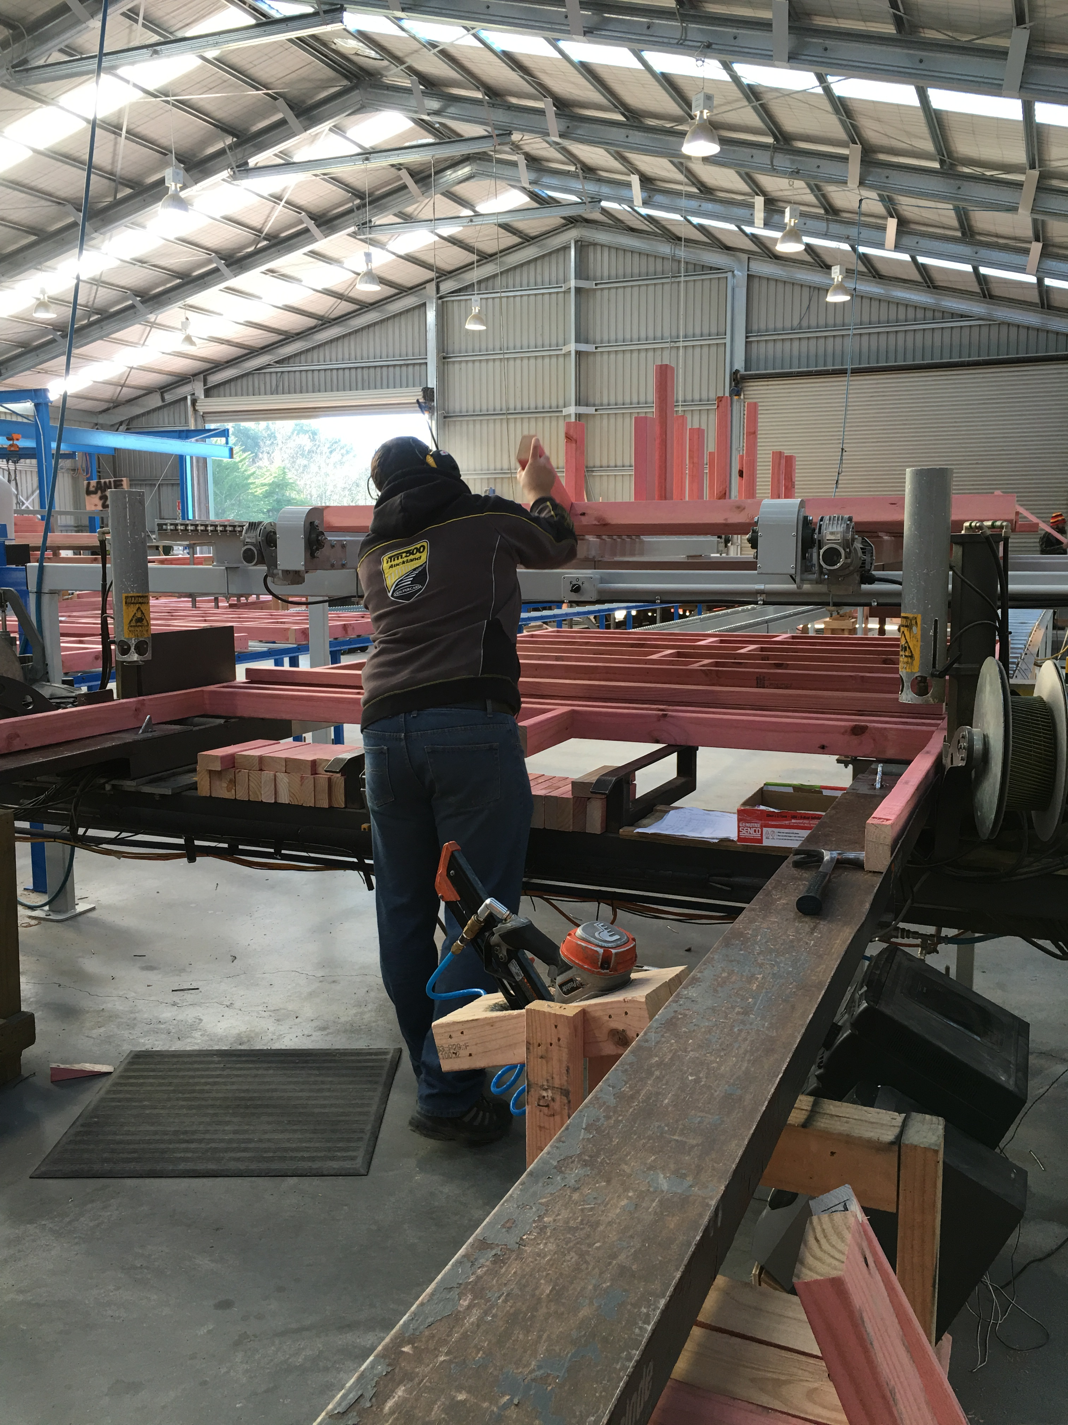 | Step | Action
 | 1 | - Place the plates from the trolley onto the auto-nailer rails.  - Check the length every 10 to ensure quality.  - Pick the prepared timber from the conveyor.

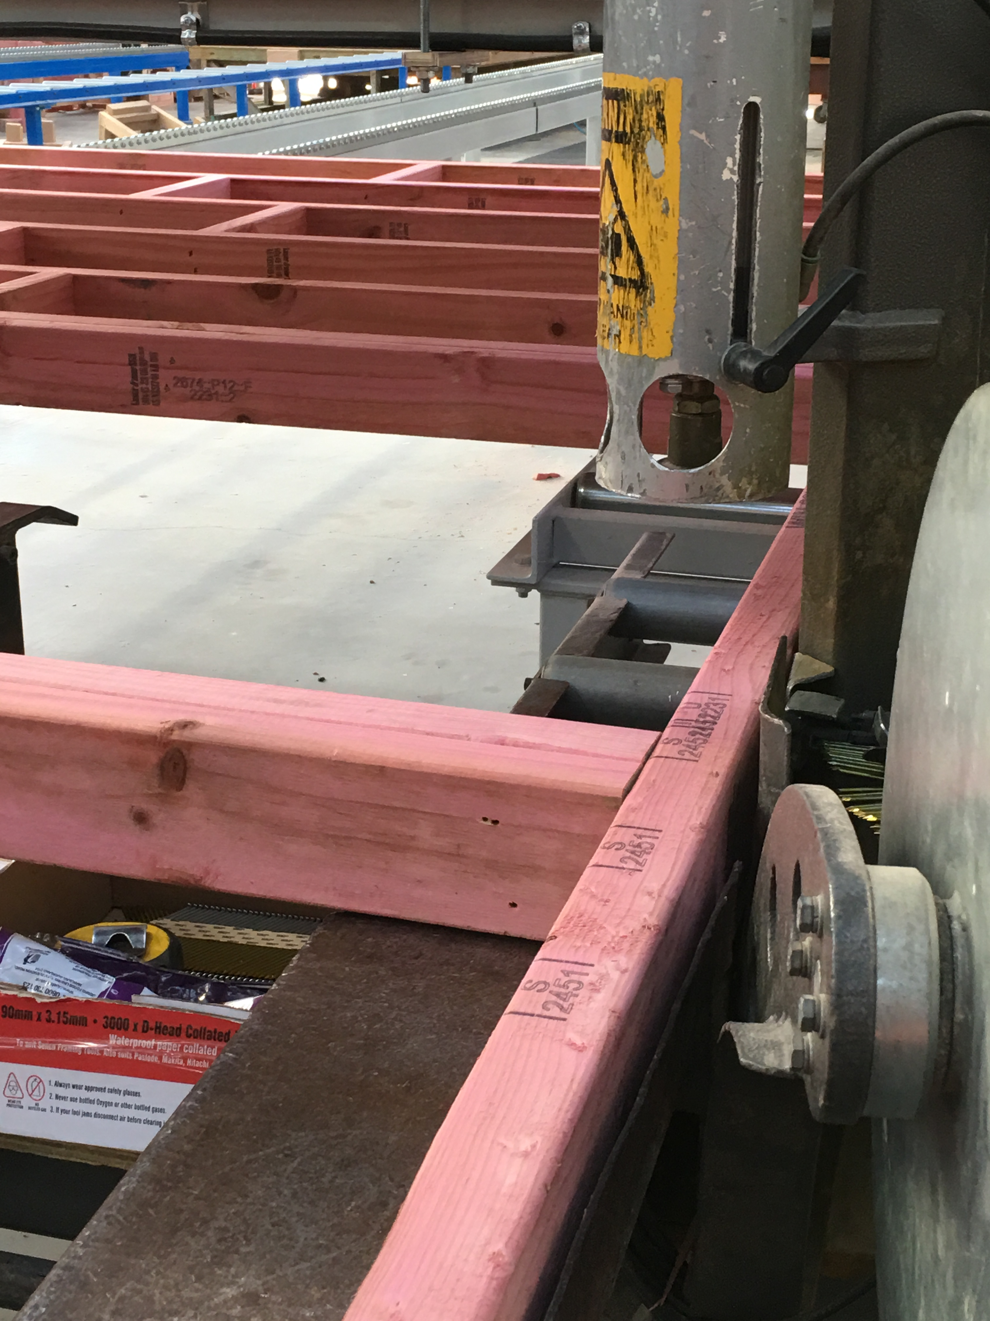 | Step | Action
 | 2 | - See the sign for the blocks to be nailed in.  - Position the prepared timber in place with the plates by aligning with the marks on the plates.

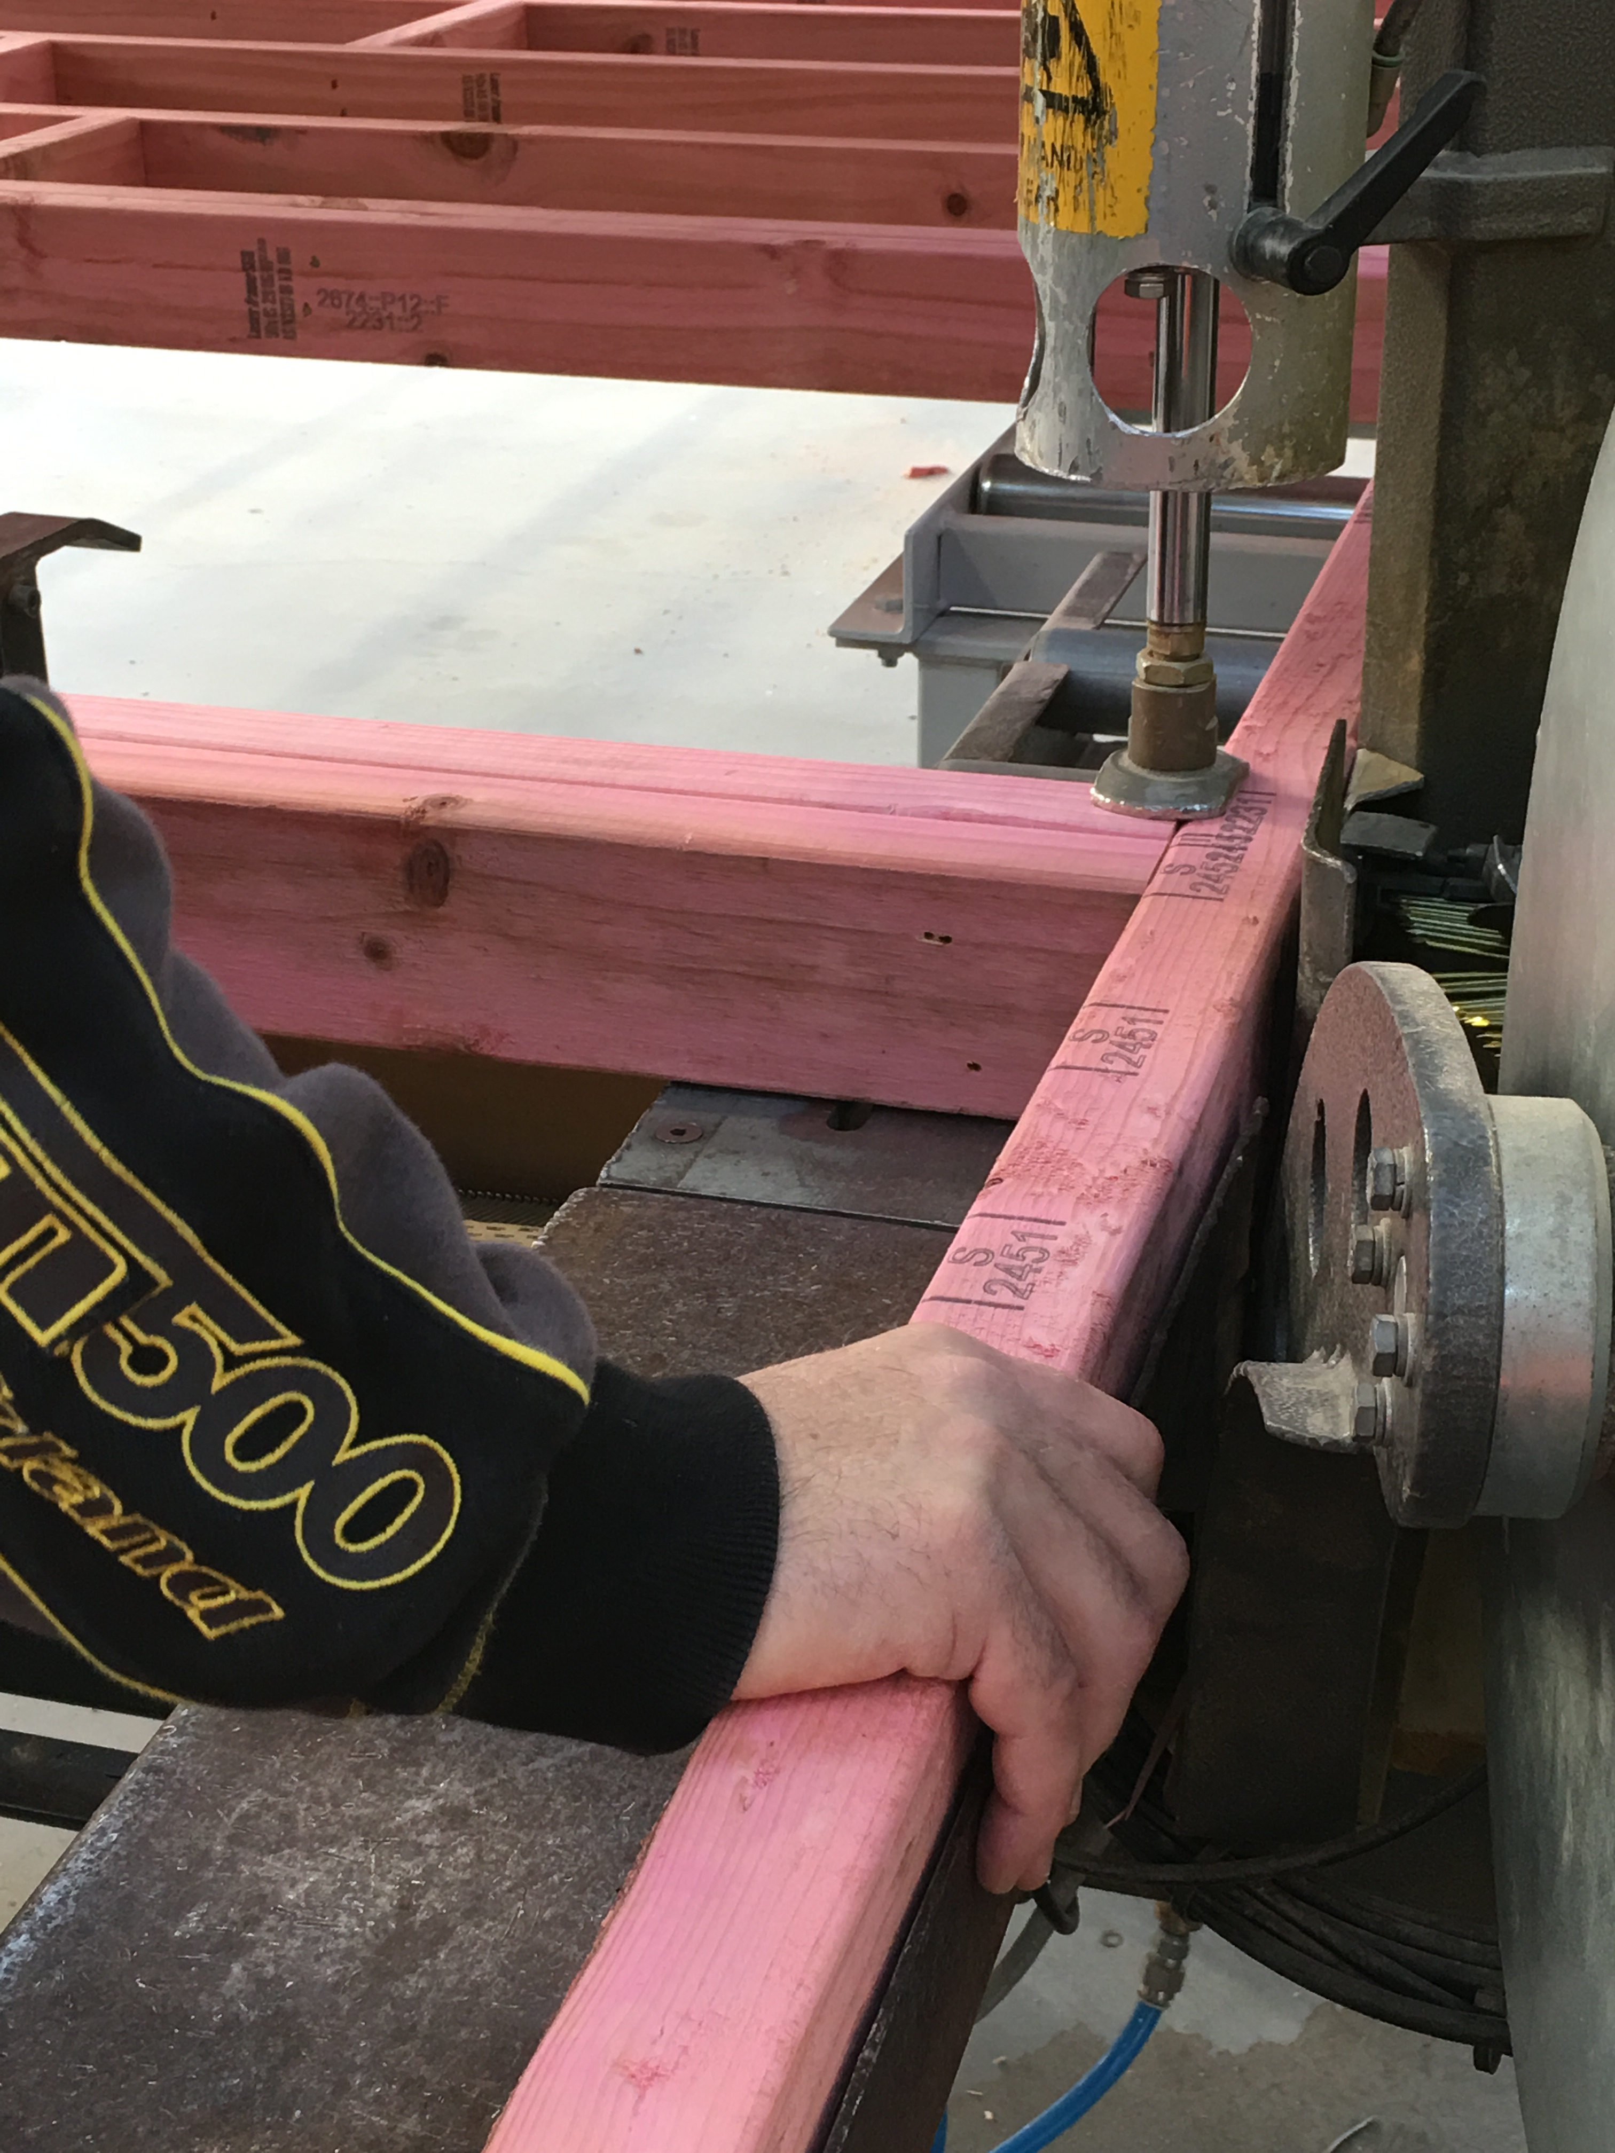 | Step | Action
 | 3 | - Push the plates up to the auto-nailer.  - Pull back against the blocks.  - When in place lower the ram to clamp the timber in place using the knee bar.  - Check coil nails and replace when needed.

 | Step | Action
 | 4 | Handheld Nail Gun  - Place the timber in the correct location to be nailed.  - Ensure your hands, other body parts and other people are out of the firing line.  - Place the nail gun in the required position.  - Fire nail gun.  - Remove so it cannot be accidently fired.

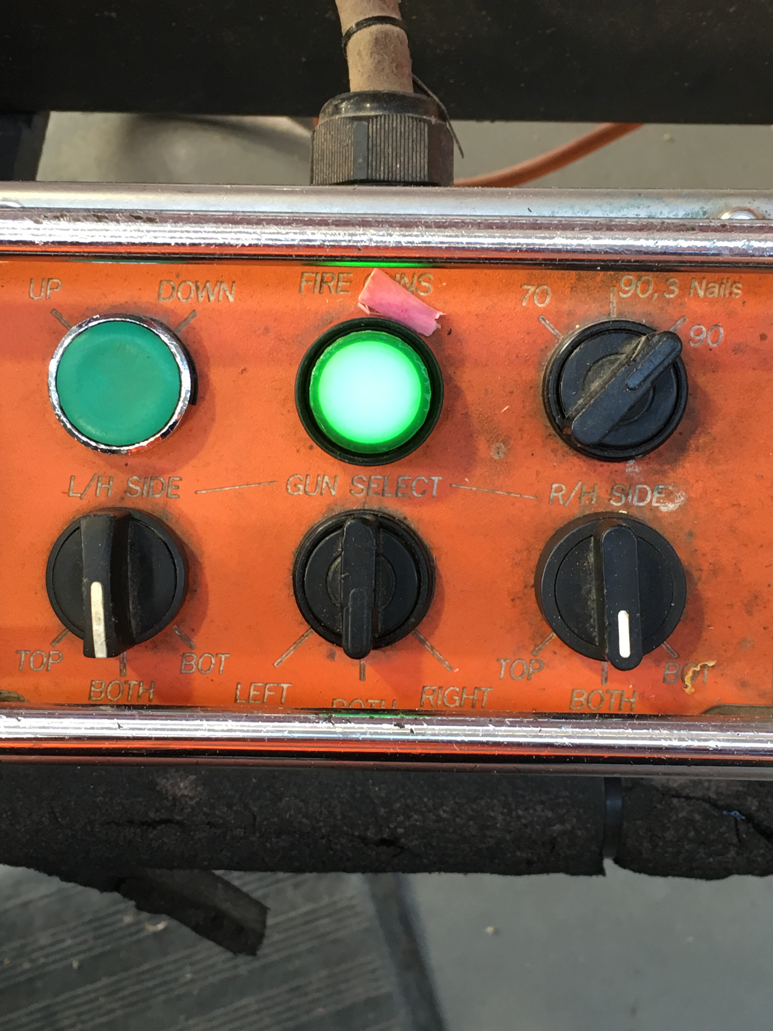 | Step | Action
 | 5 | - The fire gun button must be illuminated before the gun can fire. This means both sensors must be covered and the timber must be clamped.  - Select the left, right or both guns using the switch.  - Stand away from the firing area and press the fire gun button.

Step | Action
6 | - Repeat the process until the frame is finished.  - Push the frame down the rails to the finishing table.

Shut Down:
Turn off the machine.

DATE | TRAINEE NAME | SIGNATURE | TRAINER | SIGNATURE

