Knuckle Crane Truck Operation
Hazards:
Hazards | Controls
Ground condition – uneven, soft ground or slopes | Ensure the truck is parked on flat, level and firm ground.  Extend the landing legs and use pads if necessary. The landing legs must be on a hard surface.
Weather – windy | Do not operate in high winds. The HIAB operator is in control of the work and his or her instructions must be complied with, including the decision that conditions are too risky to continue.
Overhead obstructions – power lines, trees, buildings | The crane must be at least 4 metres away from any power line. If it is operated closer than this a permit is required.  Check for other overhead obstructions and ensure that the crane has room to manoeuvre.
Weight of load – load is too heavy and may cause HIAB to fail or truck to fall | Know the weight of the load.  Use suitable lifting chains or slings for the load.  Check the weight of the load before lifting to ensure it is within limits.  Ensure loads are lifted in a balanced state; carry out a trial lift to test the correct centre of mass.
Operator – may be crushed by HIAB or load | Gloves, safety boots and hard hat must be worn.  Do not stand between the truck and the load.  Do not stand between the load and its destination.  Do not stand under the load.  Ensure the remote control is turned off and removed from the operator as soon as the task has finished.
Others on site | Ensure there is nobody close to the load or truck.  Do not allow others to stand between the truck and the load.  Do not allow others to stand between the load and its destination.  Do not allow others to stand under the load.
Condition of truck and HIAB | Check lifting chains and slings for condition.  Chains and slings should be certified annually.  The truck mounted crane must be certified.
Communication – poor communication | The type and method of communication must be clearly understood by all parties before work commences.

PPE:

Qualification:
Only trained and authorised staff are to operate the HIAB. HIAB operators must have successfully completed unit standard 16617: Use a truck loader crane to lift and place loads. They must comply with the learnings from this training, and with the rules of the site.

Pre-operation:
Follow the daily truck pre-operative check sheet. This must be done daily before the truck is operated.

Ensure that the check includes:
- Water
- Oil
- Hydraulic fluid
- Fuel
- Tyres
- COF
- Registration
- HIAB certification
- Chain certification
- Hydraulic hoses
- PPE

Once the check sheet is completed, it must be handed in to the office. Any faults must be notified to the manager, written on the whiteboard and the maintenance sheet.

Operation: Loading Trucks

Step | Action
1 | - Identify the load. Ensure the truck is loaded so that the first item on is the last item off.  - Check the weight of the load on the delivery dockets and the side of the load.

 | Step | Action
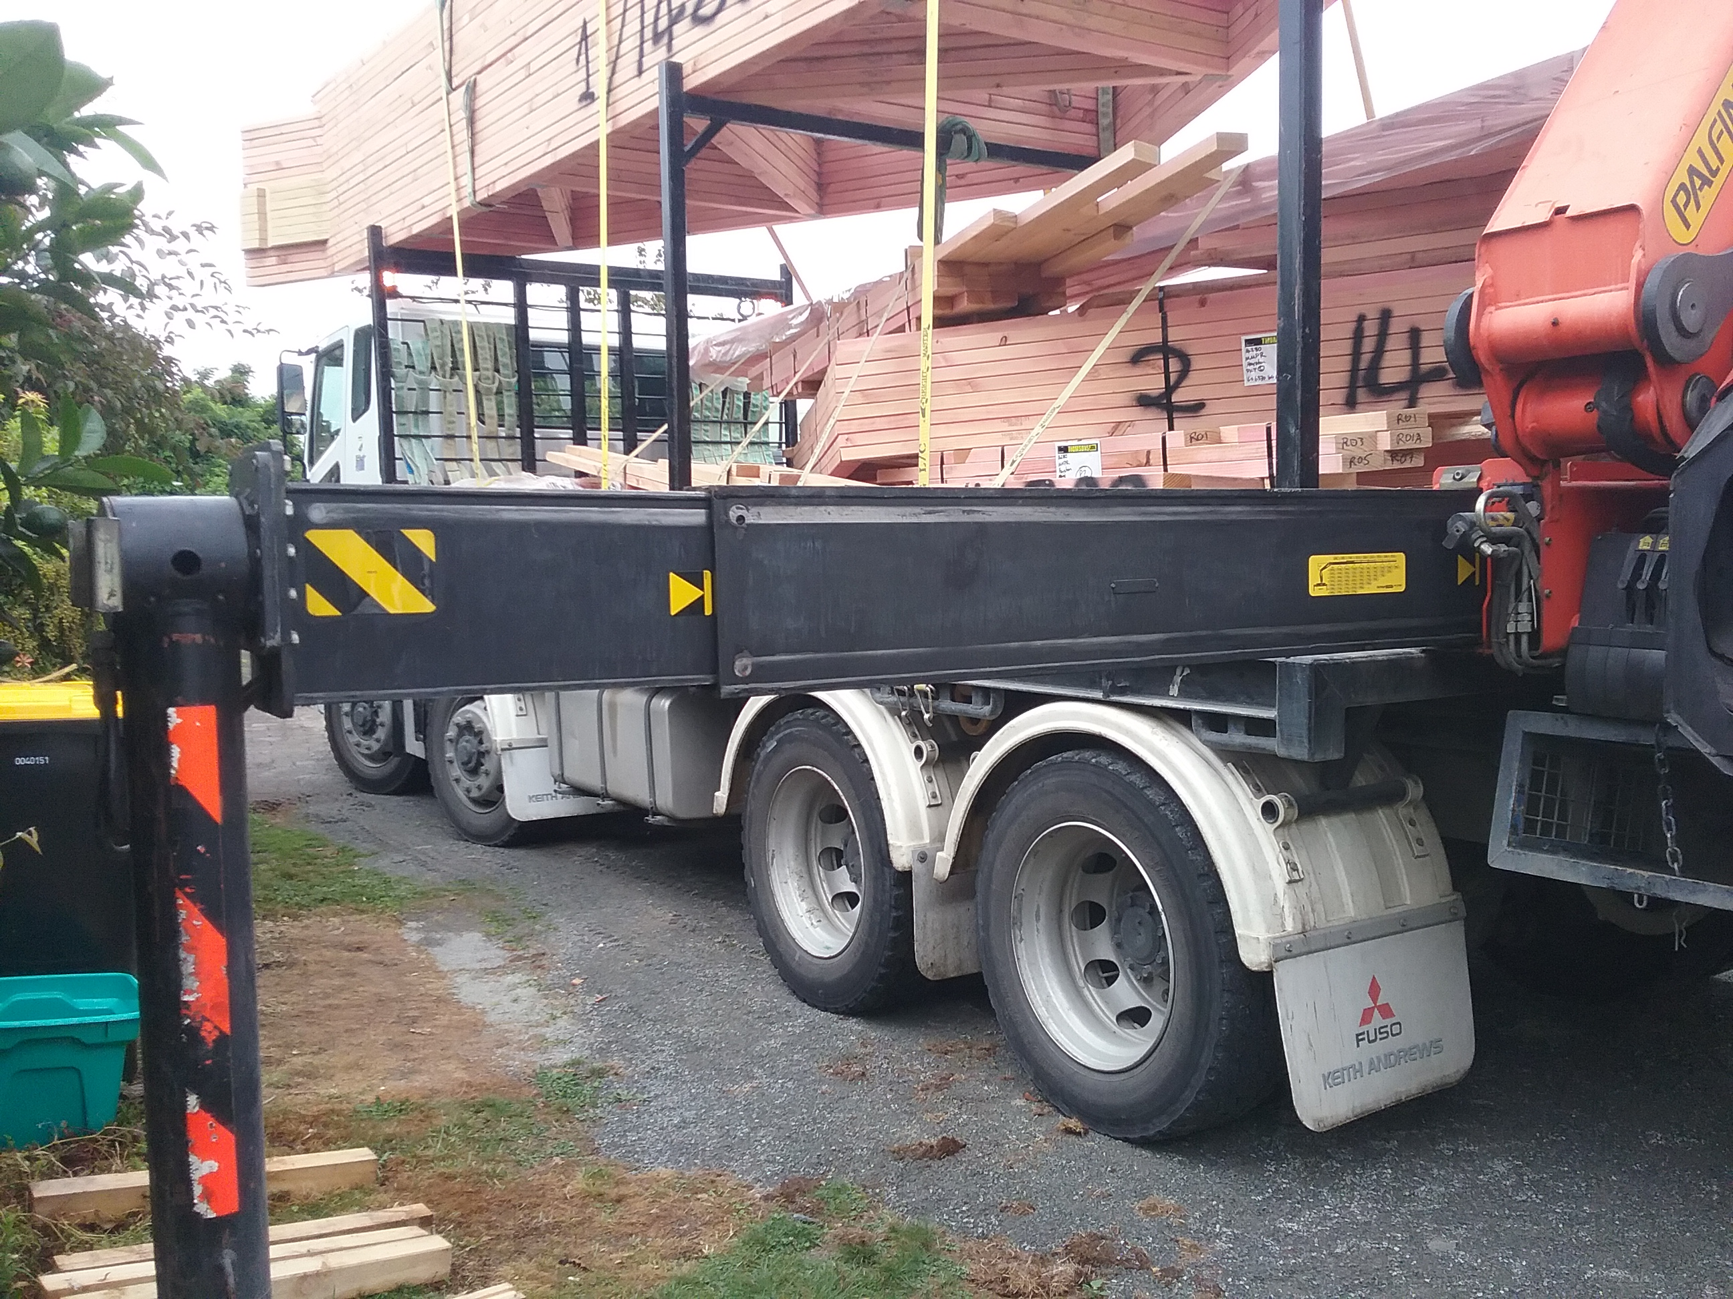 | 2 | - Park the truck as close to the load as possible.  - Check for overhead obstructions, remaining 4 metres from any power lines.  - Ensure the ground is firm, even and level. Ensure there are no drains, holes or soft spots.  - Place pads on the ground for the stabiliser legs to rest on. Make sure the pads are flat on the ground, not resting on other objects such as kerbs or clutter.  - Extend the stabiliser legs and lower to the ground.  - The stabiliser legs and truck wheels must be on the ground to support the truck.

 | Step | Action
 | 3 | - Place the straps or chains around the load, ensuring that the centre of gravity is well balanced and that the load will not tip.  - Check the safe working load (SWL) to assess weight of load, available height and distance load can be lifted.

 | Step | Action
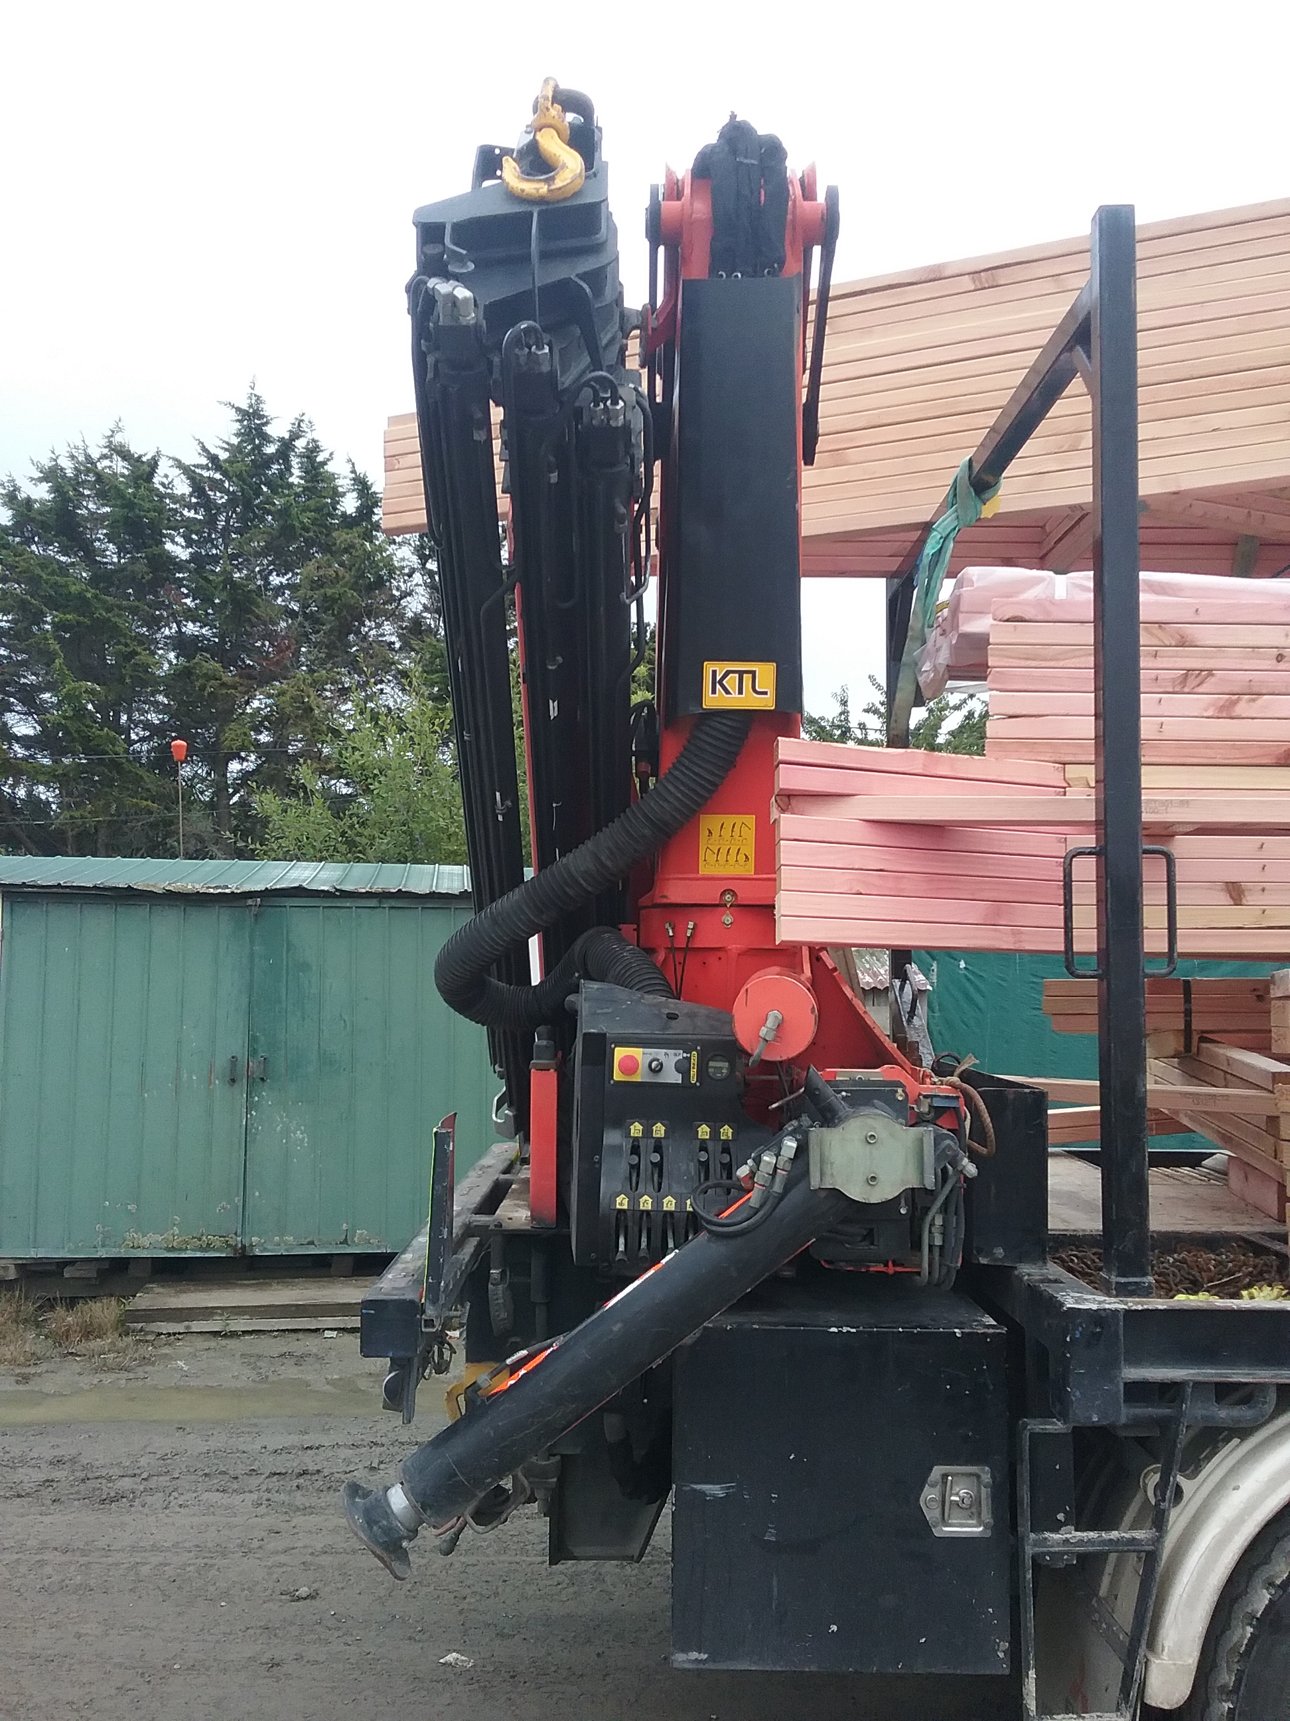 | 4 | - Stand in the safe zone of the truck – at either end.  - Using the remote control, extend the arm and attach to the straps.  - Pick up the load, ensuring it is within the safe working load of the crane. Do a test lift first.  Ensure that the work area is clear of people. Do not let anyone stand under the load or in the path of the load.  If you cannot see the other people in the vicinity, stop until you know they are in a safe position.

 | Step | Action
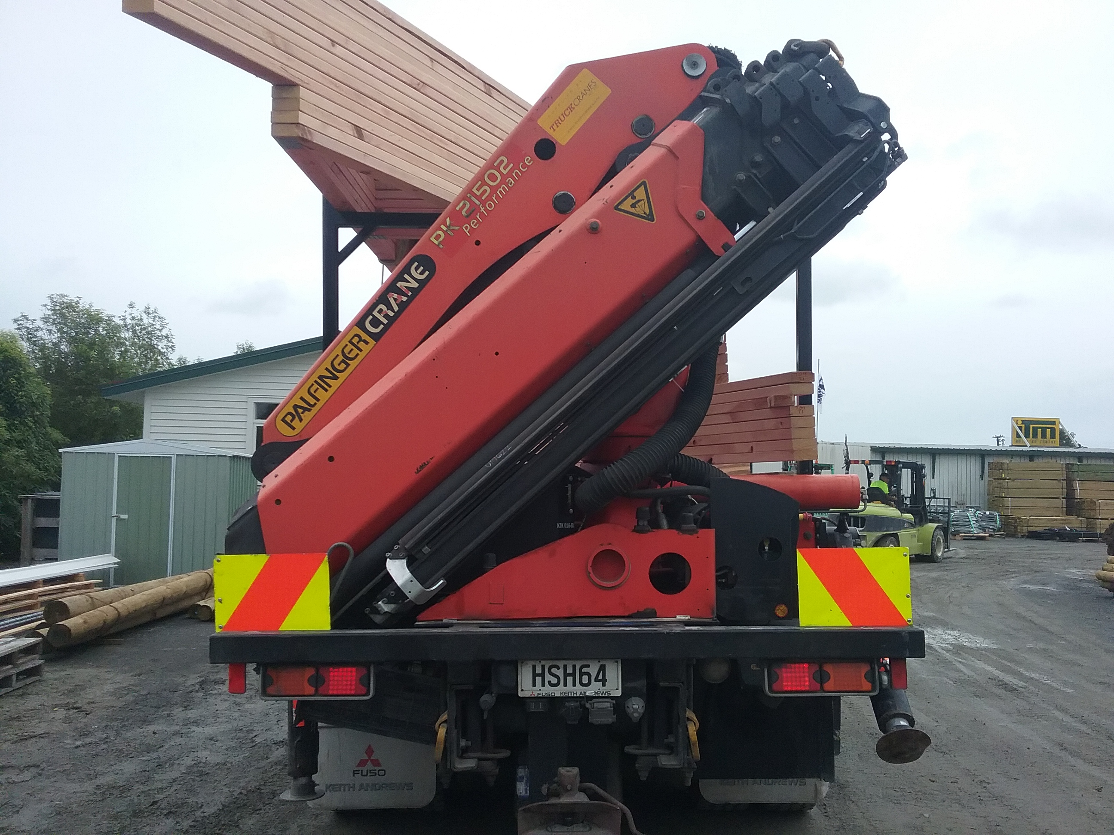 | 5 | - Manoeuvre the load onto the truck.  - Place flat on the truck.  - Remove the hook and fold HIAB away.  - Using appropriate load security, tie the load to the truck.  Ensure that the work area is clear of people. Do not let anyone stand under the load or in the path of the load.  If you cannot see the driver, or any other person in the vicinity, stop until you know they are in a safe position.

 | Step | Action
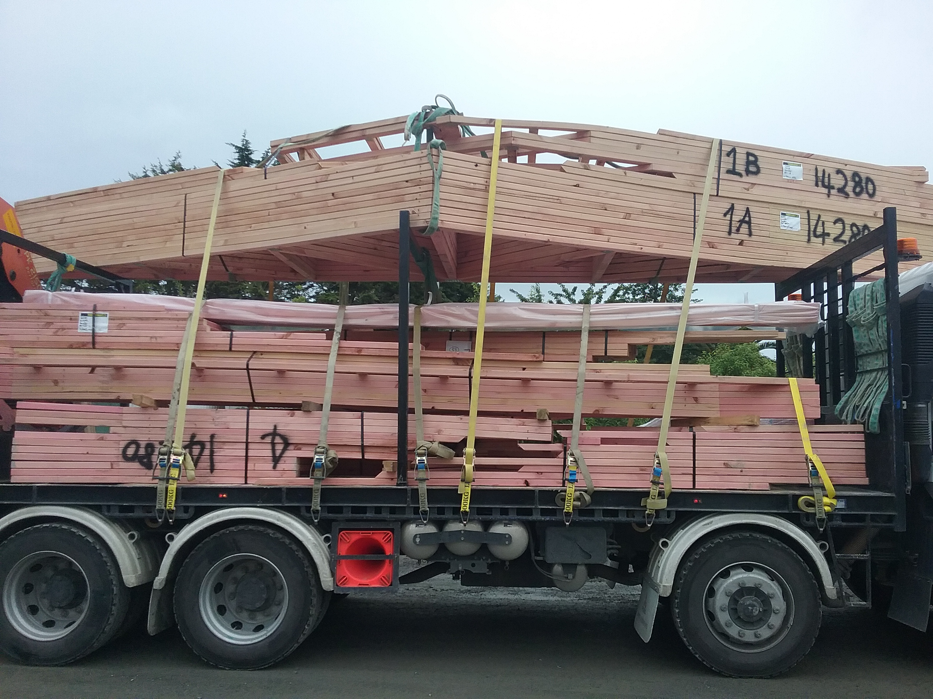 | 6 | - Retract stabiliser legs and lock in place.  - Pick up and stow pads.  - Walk around the truck to ensure the crane is secure and there are no loose items on the truck.  - Drive to delivery location.

 | Step | Action
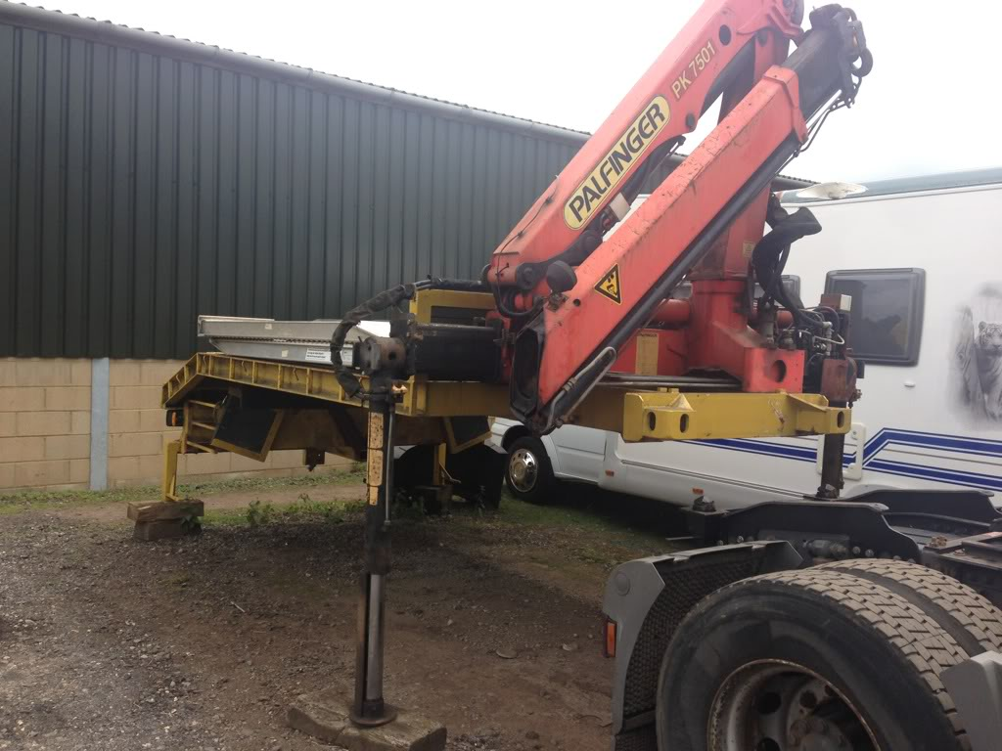 | 7 | - Park the truck as close to the delivery area as possible.  - Check for overhead obstructions, remaining 4 metres from any power lines.  - Ensure the ground is firm, even and level. Ensure there are no drains, holes or soft spots.  - Place pads on the ground for the stabiliser legs to rest on. Make sure the pads are flat on the ground, not resting on other objects such as kerbs or clutter.  - Extend the stabiliser legs and lower to the ground.  - The stabiliser legs and truck wheels must be on the ground to support the truck.

 | Step | Action
 | 8 | - Ensure the others on site are aware of the unloading plan. Establish the method of communication.  - Stand in the safe zone of the truck – at either end.  - Using the remote control, extend the arm and attach to the straps.  - Pick up the load, ensuring it is within the safe working load of the crane. Do a test lift first.  - Swing the load to the appropriate place.  - Do not remove the crane until the load is secured and stable.  Ensure that the work area is clear of people. Do not let anyone stand under the load or in the path of the load.  If you cannot see any of the other people in the vicinity, stop until you know they are in a safe position.

 | Step | Action
 | 9 | - Once the delivery is completed, retract stabiliser legs and lock in place.  - Pick up and stow pads.  - Walk around the truck to ensure the crane is secure and there are no loose items on the truck.  - Drive to next location.

Shut Down:
Park the truck as per company requirements. Place key in the appropriate place.

DATE | TRAINEE NAME | SIGNATURE | TRAINER | SIGNATURE

