Forklift Operation in Yard
Hazards:
Hazards | Controls
Other traffic – trucks and customer cars on site | There are set loading and unloading points for trucks.  Customer cars and forklifts are seldom in the same area.  The speed limit on site is 5km/hr.  Truck drivers must stand in designated areas during loading and unloading.  If the forklift operator cannot see the driver, or other person, s/he must stop work until the person is in a safe position.  Use flashing light and horn to warn others of the forklift’s presence.
Pedestrians on site | Pedestrians and forklift operators must be aware of their surroundings.  Pedestrians must give way to forklift operators.
Falling stacks/product | Product must be loaded and unloaded in designated areas.  Stack the product no more than 3 high to 1 wide.

PPE:

Qualification:
Only trained and authorised staff are to operate the forklift. Forklift operators must hold a current F endorsement and a current operator certificate. They must comply with the learnings from this training, and with the rules of the site.

Pre-operation:
Follow the daily forklift pre-operative check sheet. This must be done daily before the forklift is operated.
Once the check sheet is completed, it must be handed in to the office. Any faults must be notified to the manager, written on the whiteboard and the maintenance sheet.

Operation: Unloading Trucks

 | Step | Action
 | 1 | - Trucks (and trailers) enter through the front entrance. They stop in the front yard.  - The forklift will unload one side of the truck at a time. The truck driver must stand by the door of the truck on the same side as the forklift operator is working.  If you cannot see the driver, or any other person in the vicinity, stop until you know they are in a safe position.

 | Step | Action
 | 2 | - Place the load in front of the stacks by the truck. This should occur as quickly as possible. Ensure product is stacked in a safe manner so that it will not fall.  - Place the dunnage in line before stacking the product on it, as per timber stacking procedure.

 | Step | Action
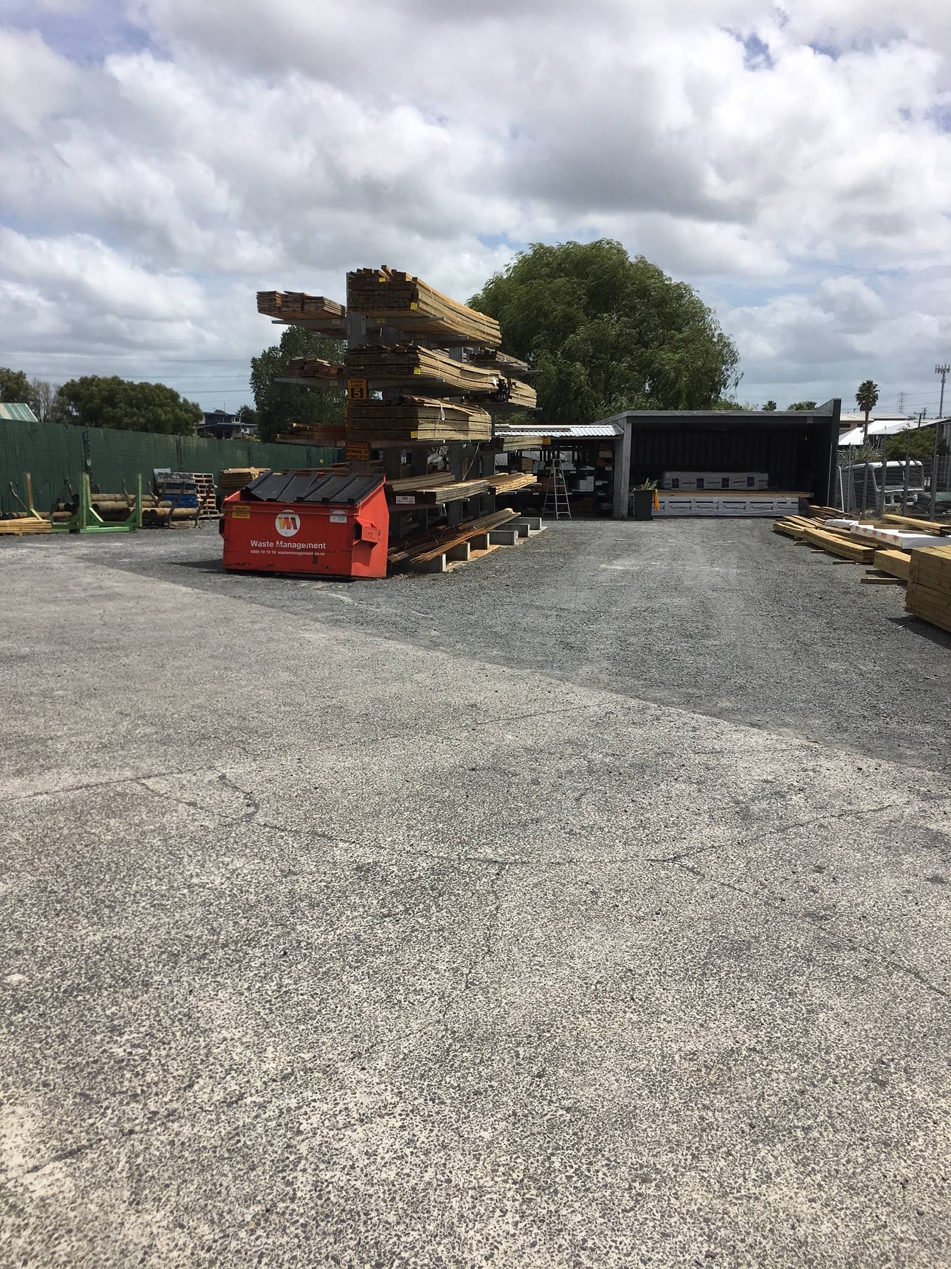 | 3 | - Place the timber in the appropriate place.  - Clear clutter away.

Shut Down: Park the forklift in the designated area. Lower the forks and tilt the mast forward so that the forks are flat on the ground. Remove the keys and place in the designated area.

DATE | TRAINEE NAME | SIGNATURE | TRAINER | SIGNATURE

