Finishing Table
Hazards:
Hazards | Controls
Noise | Class 5 hearing protection must be worn. These may be ear plugs or ear muffs.
Manual handling | Use appropriate lifting techniques: bend your knees, not your back. Do not twist. Turn using your feet and keeping your body straight.  Hold timber close to your body.  Gloves are provided and are optional.
Nail gun operation | Only trained and authorised people are to operate the nail gun.  The operator’s hands must be away from the firing area.  Nail the bottom of the timber first.
Trip hazards | Be aware of where the air hose is. Keep it out of the way.

PPE: 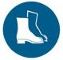 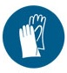

Qualification:
Only trained and authorised staff are to work at the finishing table.

Pre-start checks:
Check the condition of the nail gun. Ensure the hoses are in good condition and the coupling is secure.

Operation: Finishing Table

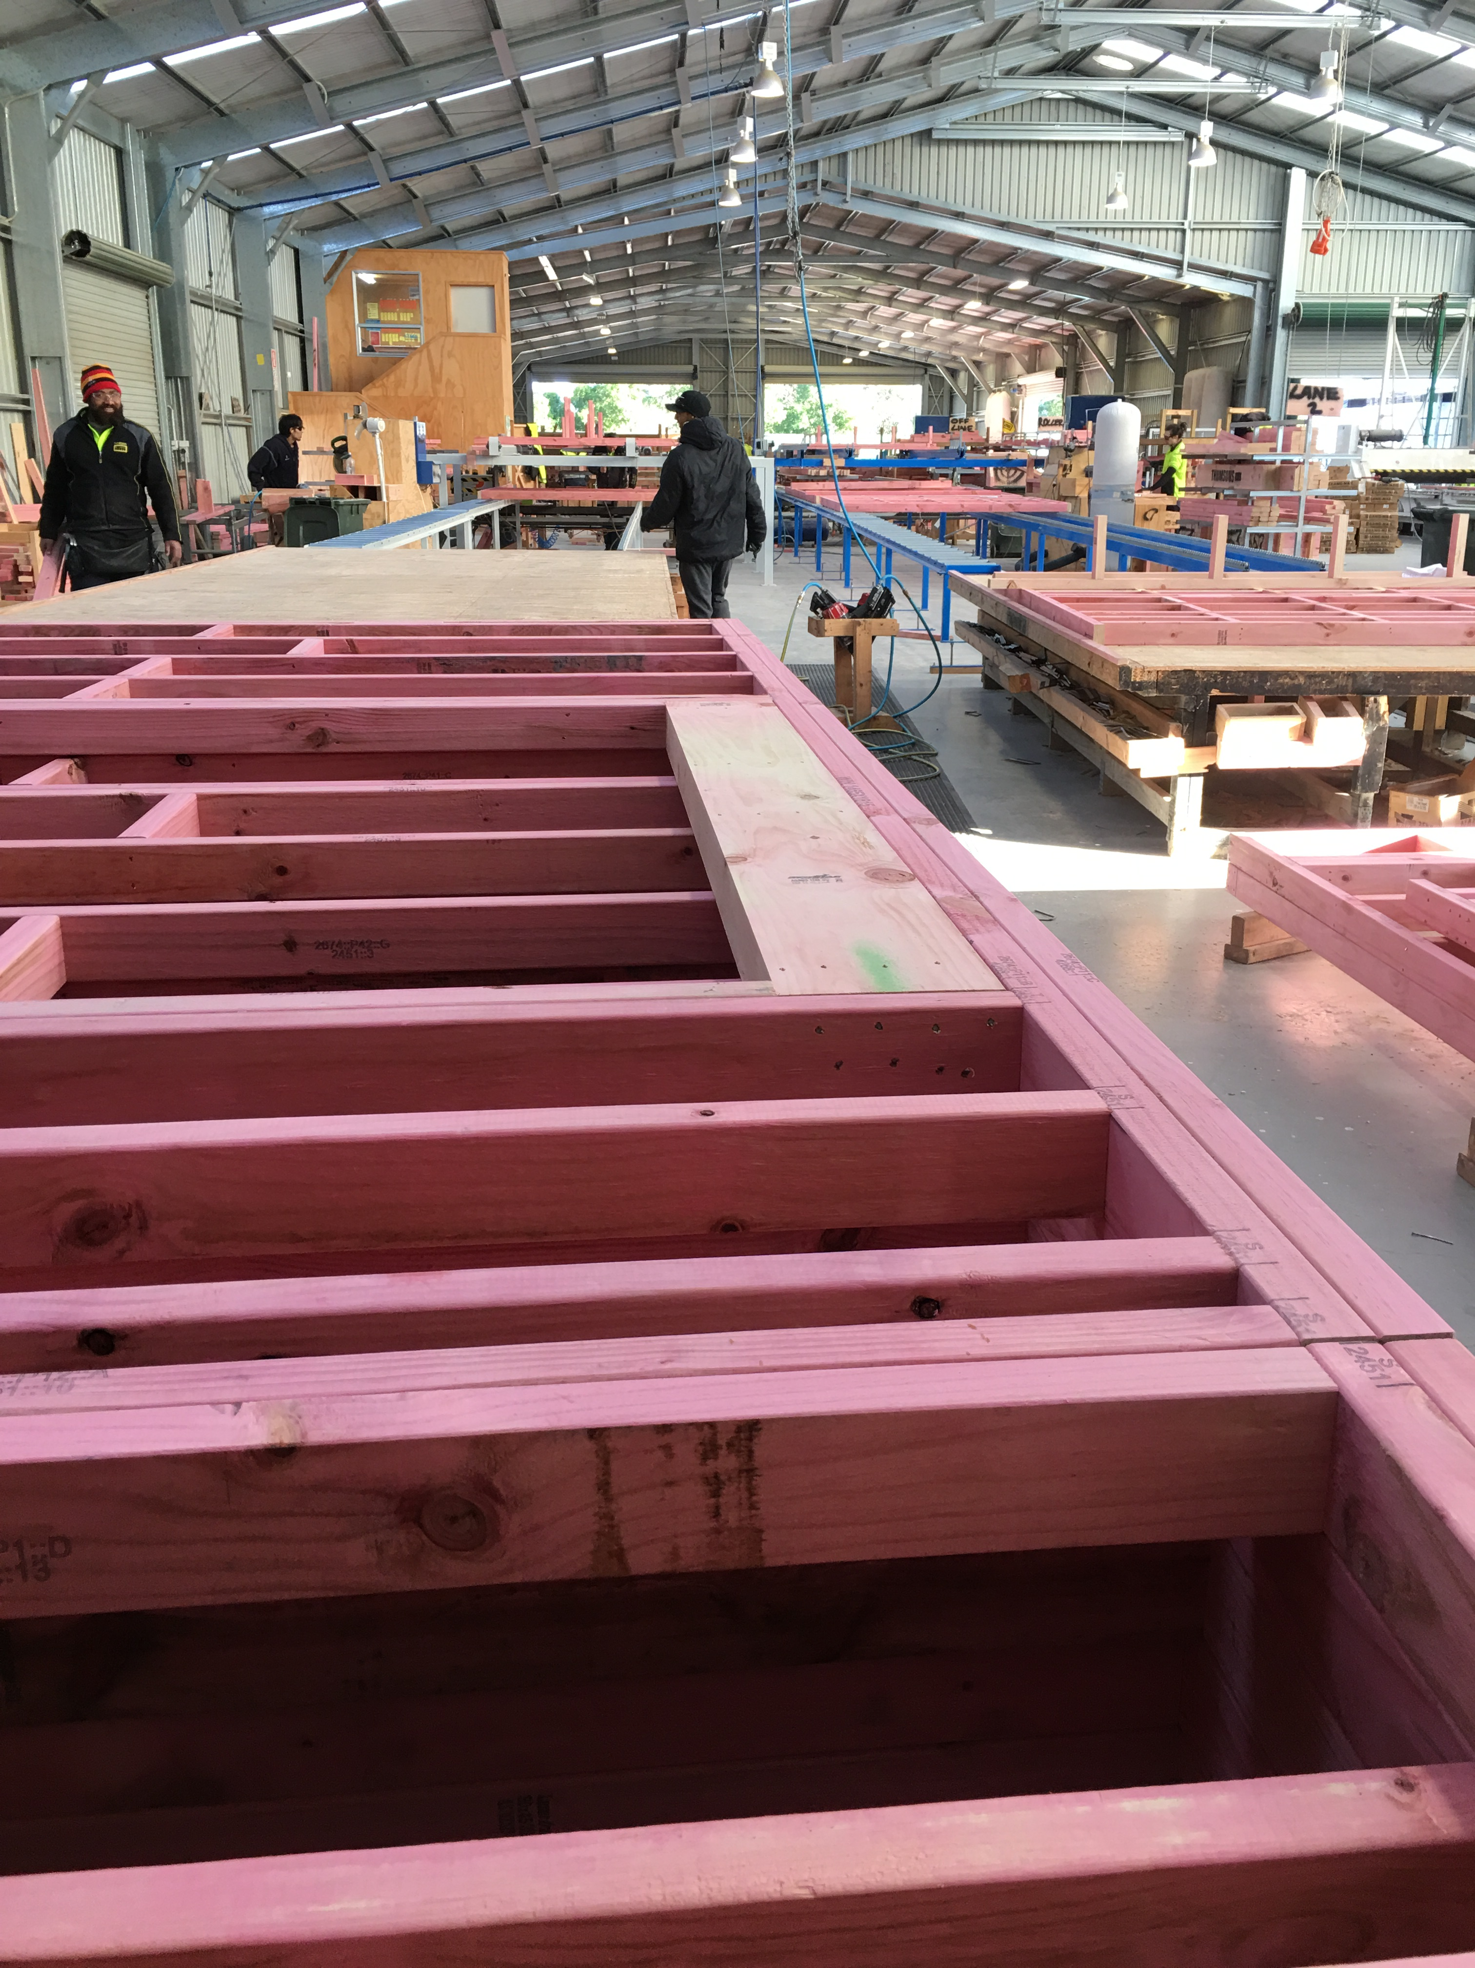 | Step | Action
 | 1 | - Add lintels, etc. as required.  - Rip down where needed to correct size.  - Shoot skew nails in from nogs to stud.

Step | Action
2 | - Check the frames to ensure there is no bowing.  - If there is bowing, remove the stud, adjust the nog and replace the stud.  - Apply additional items such as angle braces, etc.  - Check overall quality and ensure it is within the customer’s expectation: all components flush, all nails nailed tidily, all timber aligned.  - Nail frames to each other, on outside of frame, for transport stability.

Step | Action
3 | - Move the frame to the stack for removal.  - Use two people if the frame is heavy.  - Strap finished product with metal band strapping.  - Wrap the finished product with plastic sheeting and nail into place.  - Apply the correct label to the finished packet.  - Check the measurements of the finished product against the label.  - Move outside for removal by the forklift operator.

Shut Down:
Tidy up the area.

DATE | TRAINEE NAME | SIGNATURE | TRAINER | SIGNATURE

