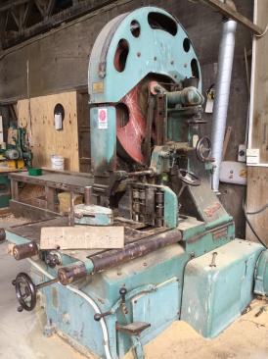
Hazards:
Bandsaw

Hazards | Controls
Noise | Class 5 hearing protection must be worn. These may be ear plugs or ear muffs.
Dust or timber shavings | Extraction system must be used. Safety glasses must be worn.
Manual handling | Use appropriate lifting techniques: bend your knees, not your back. Do not twist. Turn using your feet and keeping your body straight. Hold timber close to your body.  Gloves are provided and are optional.  Avoid maintaining awkward positions for prolonged periods.
Others in the area | Be aware of where people or other equipment are when moving timber.
Trip hazards | Keep the area clear from clutter. Clean as you go.
Pinch points | Guards must be fitted. Keep hands and other body parts away from pinch points.

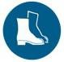
PPE: Optional

Qualification:
Only trained, authorised and signed-off staff are to work at the bandsaw.

Emergency Stop:

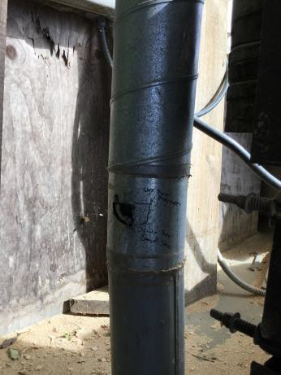Pre-start checks:
Clear the work area of any clutter, both on the infeed and outfeed sides. Check for birds’ nests inside the bandsaw.
Remove any packets of timber that are in the way.
Cone off the area if using a trolley.
Ensure the extraction bin is not full. If it is, empty it.

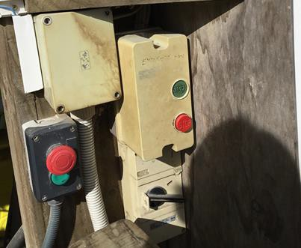Operation: Bandsaw

 | Step | Action
 | 1 | Turn on the extraction system.
 | 2 | Check the flap to make sure it is set for bandsaw.
 | 3 | Turn on the main power.  Check the emergency stops are out.
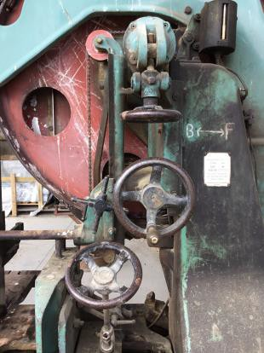 | 4 | Adjust tension using the wheel. The top of the arm must be in line with the black mark.  Spin the top wheel at least two full turns to make sure the blade is running correctly.

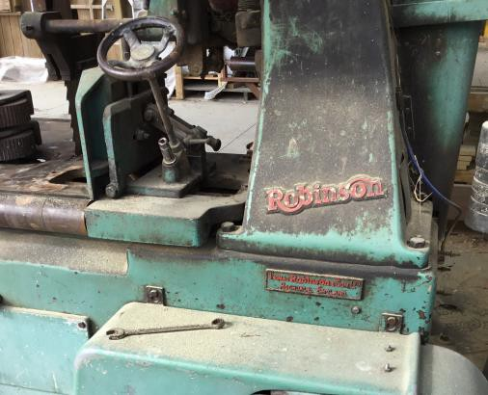
 |  | Check blade teeth are set correctly (1mm from back of teeth running to top wheel). Adjust if necessary.
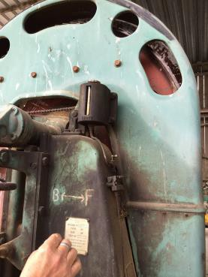 | 5 | Check the level of the lubricant and top up if necessary.
 | 6 | Set timber measurement block to correct size.
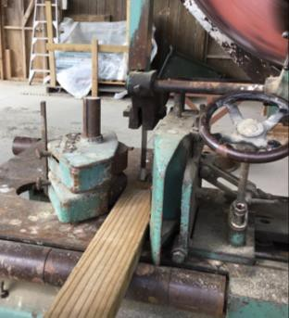 | 7 | Set timber feed to the correct position.

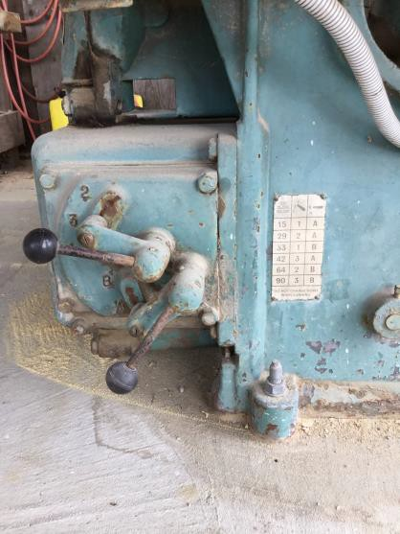 | 8 | Check gearing is correct for timber feed using the levers and the chart.
 | 9 | Turn on the bandsaw.
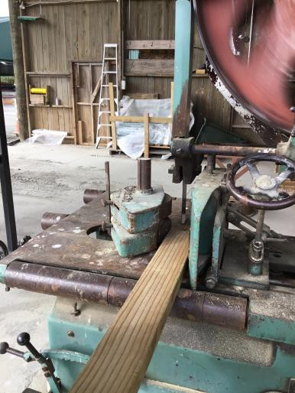 | 10 | Feed the timber into the bandsaw.  Once it is self-feeding, let go and move to the outfeed area to catch the timber. It should be supported by trestles.  Load the timber on to the trolley for removal.

Shut Down:
Turn off the bandsaw using either emergency stop. Be aware the machine may be hot so do not touch it.
Turn off the extraction system. Tidy up the area.
Hand in any paperwork

DATE | TRAINEE NAME | SIGNATURE | TRAINER | SIGNATURE

