Automatically Operated Auto-Nailer
Hazards:
Hazards | Controls
Noise | Class 5 hearing protection must be worn. These may be ear plugs or ear muffs.
Manual handling | Use appropriate lifting techniques: bend your knees, not your back. Do not twist. Turn using your feet and keeping your body straight.  Hold timber close to your body.
Auto-nailer gun operation | The timber must be clamped and the sensors at the nail guns must be covered to illuminate the gun fire button.  Keep way from the firing area.
Nail gun operation | Only trained and authorised people are to operate the nail gun  The operator’s hands must be away from the firing area.  Nail the bottom of the timber first.
Trip hazards | Be aware of where the air hose is. Keep it out of the way.
Pushing trolleys | Trolleys are fitted with quality, sealed wheels and are well maintained.

PPE:

Qualification:
Only trained and authorised staff are to work at the automatically operated auto-nailer.

Pre-operation:
Check the condition of the nail gun. Ensure the hoses are in good condition and the coupling is secure.

Operation:

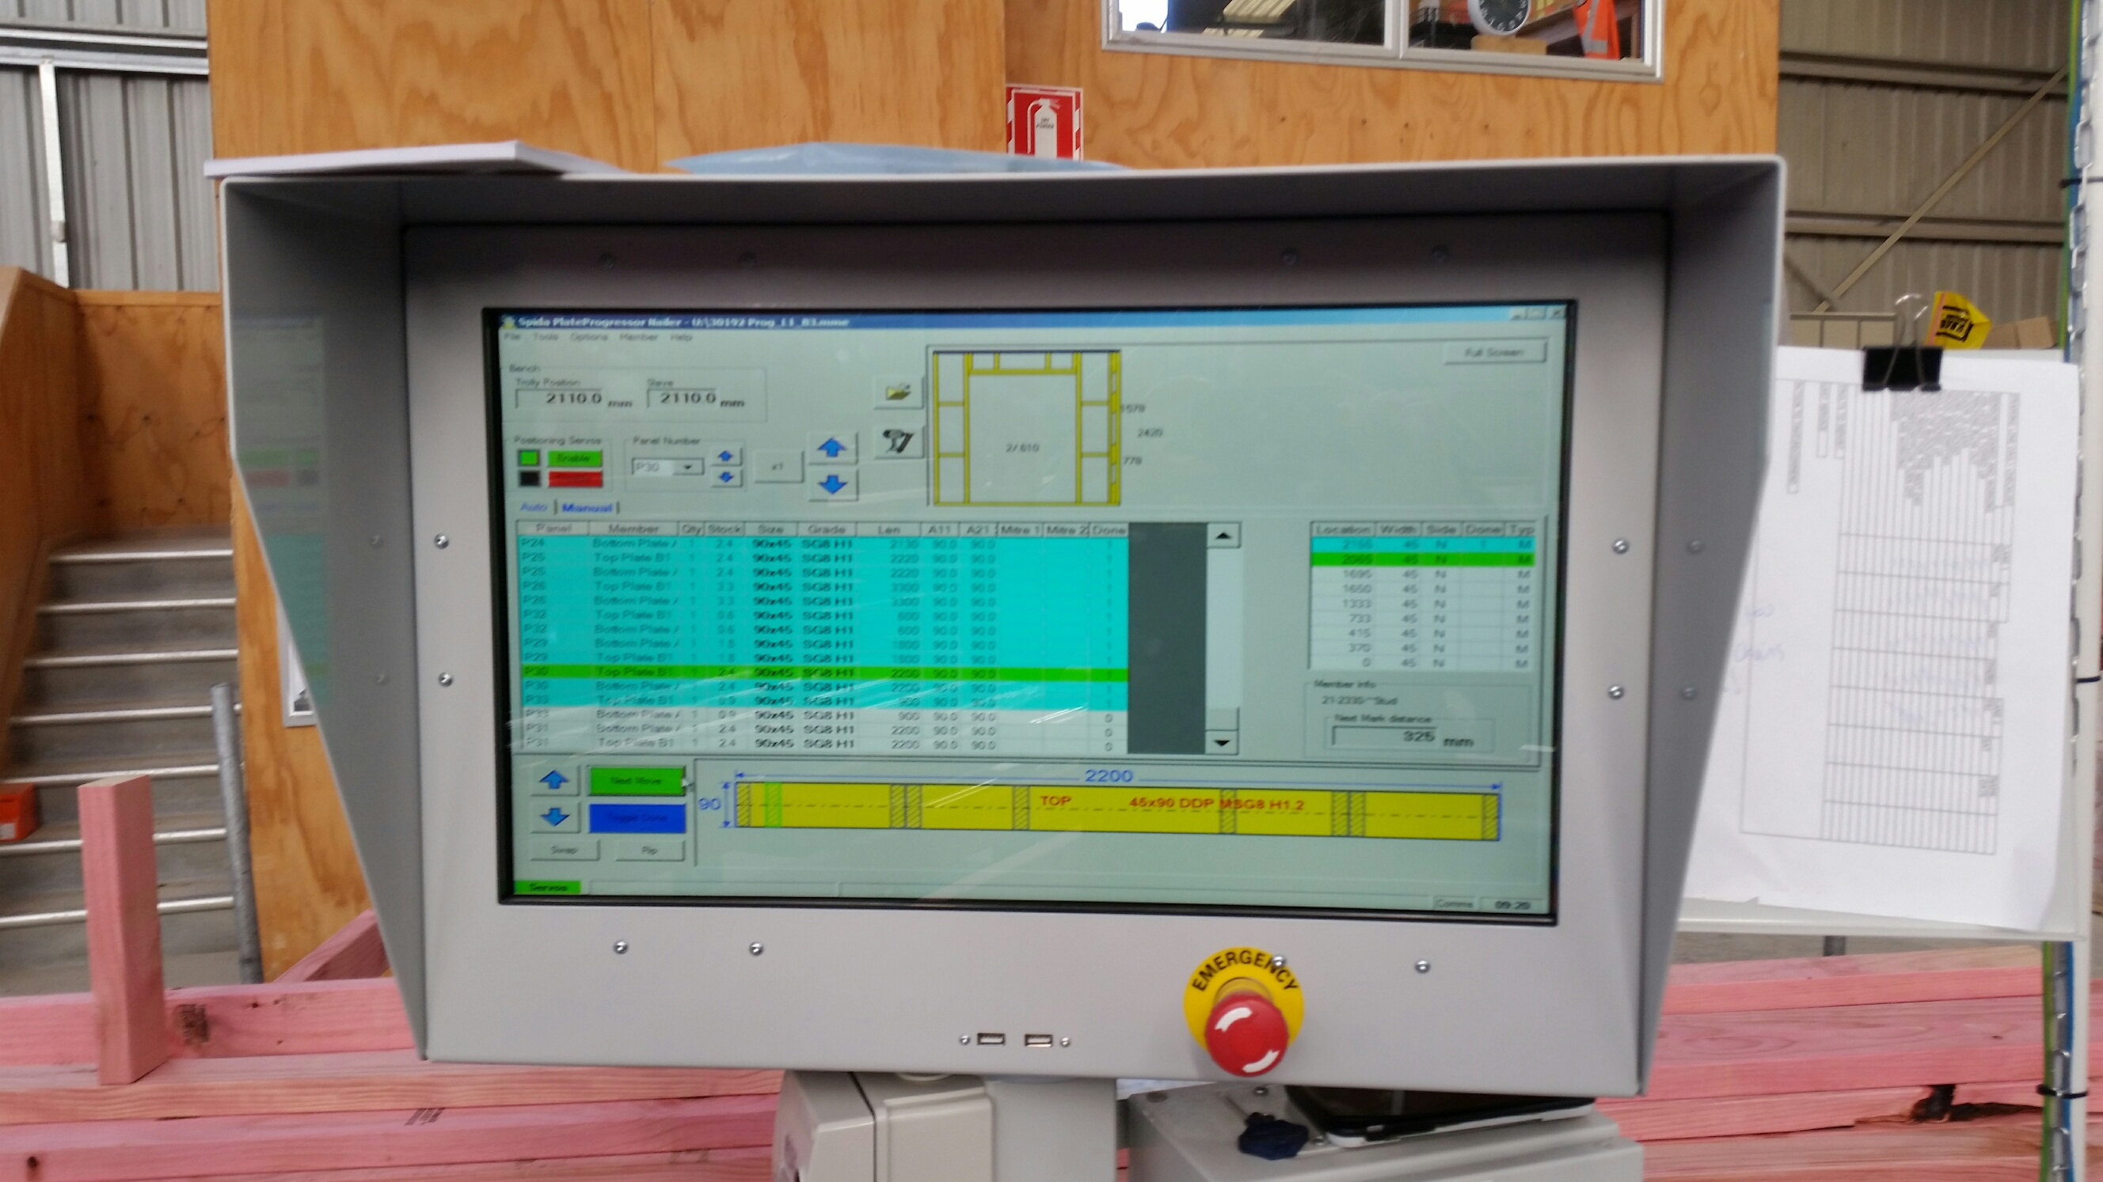 | Step | Action
 | 1 | - Turn on the computer and select the correct plan.  - Place the plates from the trolley onto the auto-nailer rails.

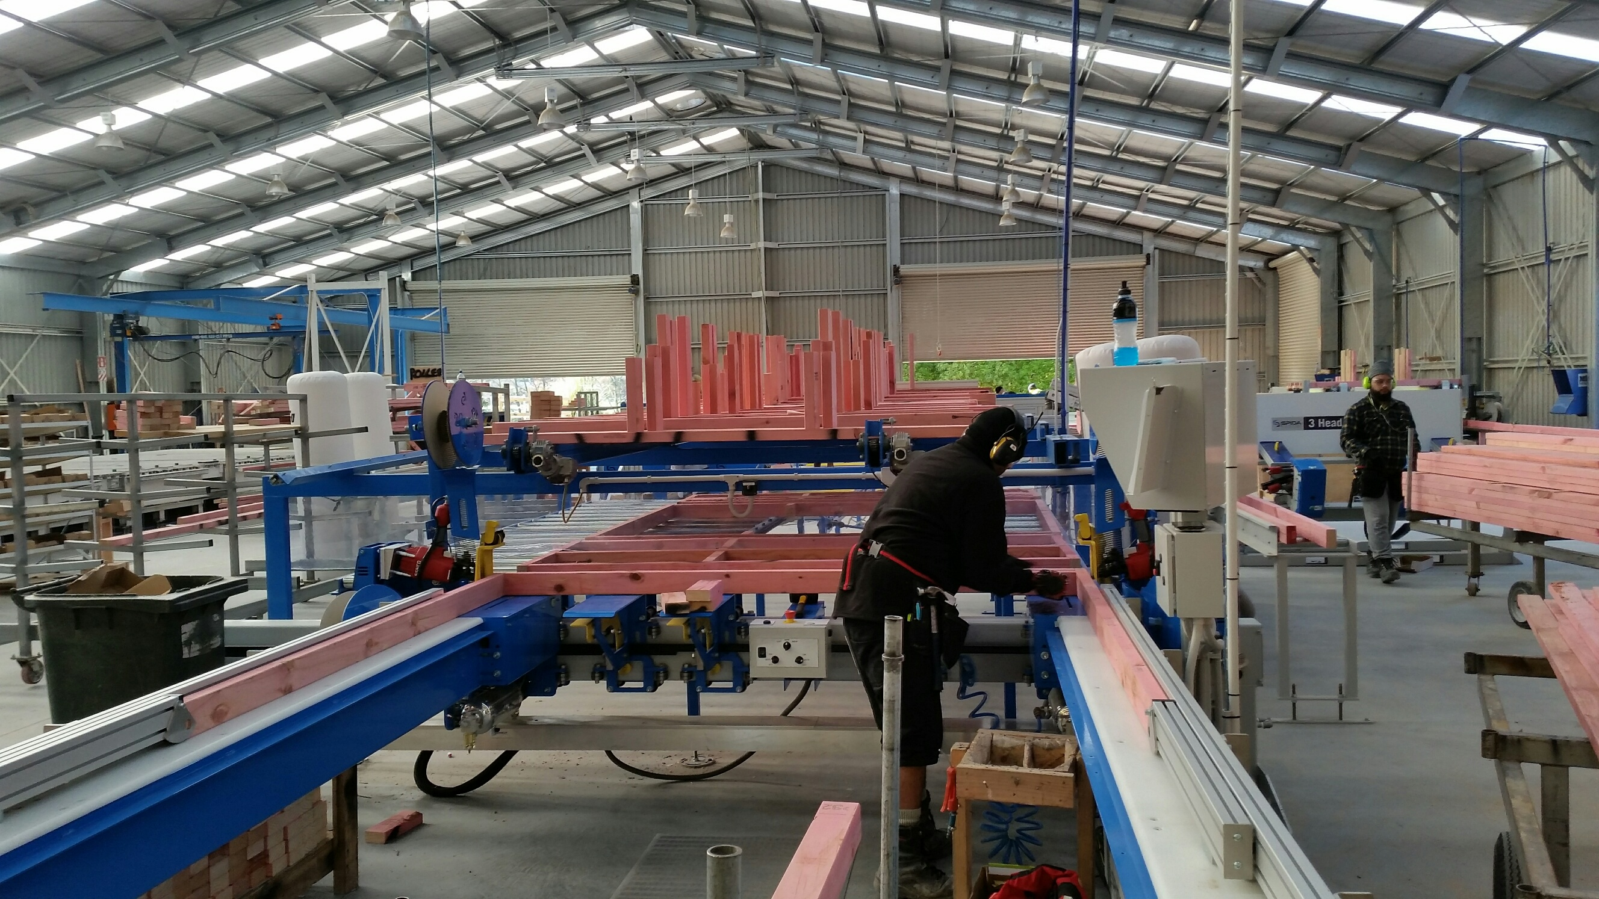 | Step | Action
 | 2 | - Pick the prepared timber from the conveyor.  - This will align automatically with the plates.

Step | Action
3 | - When in place, lower the ram to clamp the timber in place using the knee bar.

Step | Action
4 | - The fire gun button must be illuminated before the gun can fire. This means both sensors must be covered and the timber must be clamped.  - Select the left, right or both guns using the switch.  - Stand away from the firing area and press the fire gun button.

Step | Action
5 | - Repeat the process until the frame is prepared.  - Push the frame down the rails to the finishing table.

Shut Down:
Turn off the machine.

DATE | TRAINEE NAME | SIGNATURE | TRAINER | SIGNATURE

